**Requirements Specifications**

**P05:HR MANAGEMENT SYSTEM**

**team member names & ids**

| **Student ID** | **Name** |
| --- | --- |
| **22100289** | **Mohammad Yousuf** |
| **22100062** | **Aamina Mariam** |
| **22100260** | **Talha Nasir** |
| **22100230** | **Javeria Tariq** |
| **22100303** | **Ali Adnan Arif** |

| **Content** | **Totals** | **Obtained** |
| --- | --- | --- |
| Introduction & system actors | 5 | 5 |
| Use case diagram | 10 | 10 |
| Use case descriptions | 20 | 10 |
| Class diagram | 20 | 2 |
| Sequence diagram | 20 | 8 |
| State diagram | 5 | 5 |
| Non-functional requirements | 5 | 5 |
| Who did what | 5 | 5 |
| Review checklist | 5 | 5 |
| Overall formatting/template | 5 | 5 |
| Late submission penalty | -20 |  |
| **Total** | **100** | **60** |
| Review | 20 |  |
| **Grand Total** |  |  |

**Table of Contents**

Introduction **4**

System Actors **5**

**Use Cases** **7**

Use Case Diagram 7

Description of Use Cases 8

3.2.1 Login 8

3.2.2 Logout 9

3.2.3 Forgot Password 9

3.2.4 Job Promotions/Demotions 10

4.2.5 HR Dashboard 11

3.2.6 Hiring Candidates 12

3.2.7 Manage Departments 12

3.2.8 Change Password 13

3.2.9 Ranking candidates 14

3.2.10 Parsing CVs 15

3.2.11 Compensation and Benefits tracking 16

3.2.12 Staff directory 16

3.2.13 Employee requests 17

3.2.14 Employee reviews 18

3.2.15 Employee performance analytics dashboard 19

3.2.16 Adding announcements 19

3.2.17 Notification panel 20

3.2.18 Employee request approval/denial 21

3.2.19 Employee reviews reminder 22

3.2.20 Hierarchy Tree 22

3.2.21 Hiring portal/ Collecting CVs 23

3.2.22 Job posting 24

3.2.23 AI chatbot - ‘Assistant’ 24

Class Diagram **26**

Description 26

Diagram 27

Sequence Diagrams **28**

5.1 Login 28

5.2 Logout 29

5.3 Change Password 30

5.4 Forgot Password 32

5.5 Job promotions/demotions 33

5.6 HR Dashboard 34

5.7 Manage Departments 35

5.8 Parsing CV’s 36

5.9 Compensation and Benefits tracking 37

5.10 Hierarchy Tree 38

5.11 Job Posting 39

5.12 Adding Announcements 40

5.13 Employee Analytics 41

5.14 Employee Requests 42

5.15 Employee Review 43

5.16 Employee Reviews Reminder 44

5.17 Hiring Portal 45

5.18 Notifications: 46

5.19 Staff directory 47

5.20 AI Chatbot 48

5.21 Hiring Candidates 49

5.22 Employee Request Accept/Denial 50

State Diagrams **51**

Diagram details 51

Diagram 51

Non-functional Requirements / Quality Attributes **52**

Review checklist **53**

# Introduction

The Human resource management system covers many HR aspects from application to management to promotions. The software keeps track of an organization’s employees and provides analytics of their performance using relevant KPIs. The software combines a number of systems and processes to ensure the ease of management in human resources and business processes. The HRMS software helps HR professionals manage the modern workforce.

Our aim is to assist companies in running effectively and efficiently. The system is a suite of software that companies can use to regulate their internal HR functions. Employee data management, recruitment, benefits, training, talent management, employee engagement, and employee attendance include some of the features our software will provide.

# System Actors

| **Actor Name** | **Description** |
| --- | --- |
| HR manager | Will have access to information and statistics of all employees. |
| System Administrator | The manager of the website |
| Dept head | Will have access to the information of employees in their own department and will be able to enter information regarding each employee |
| Employee | Will have access to their information/analytics dashboard |

# 

# Use Cases

## Use Case Diagram

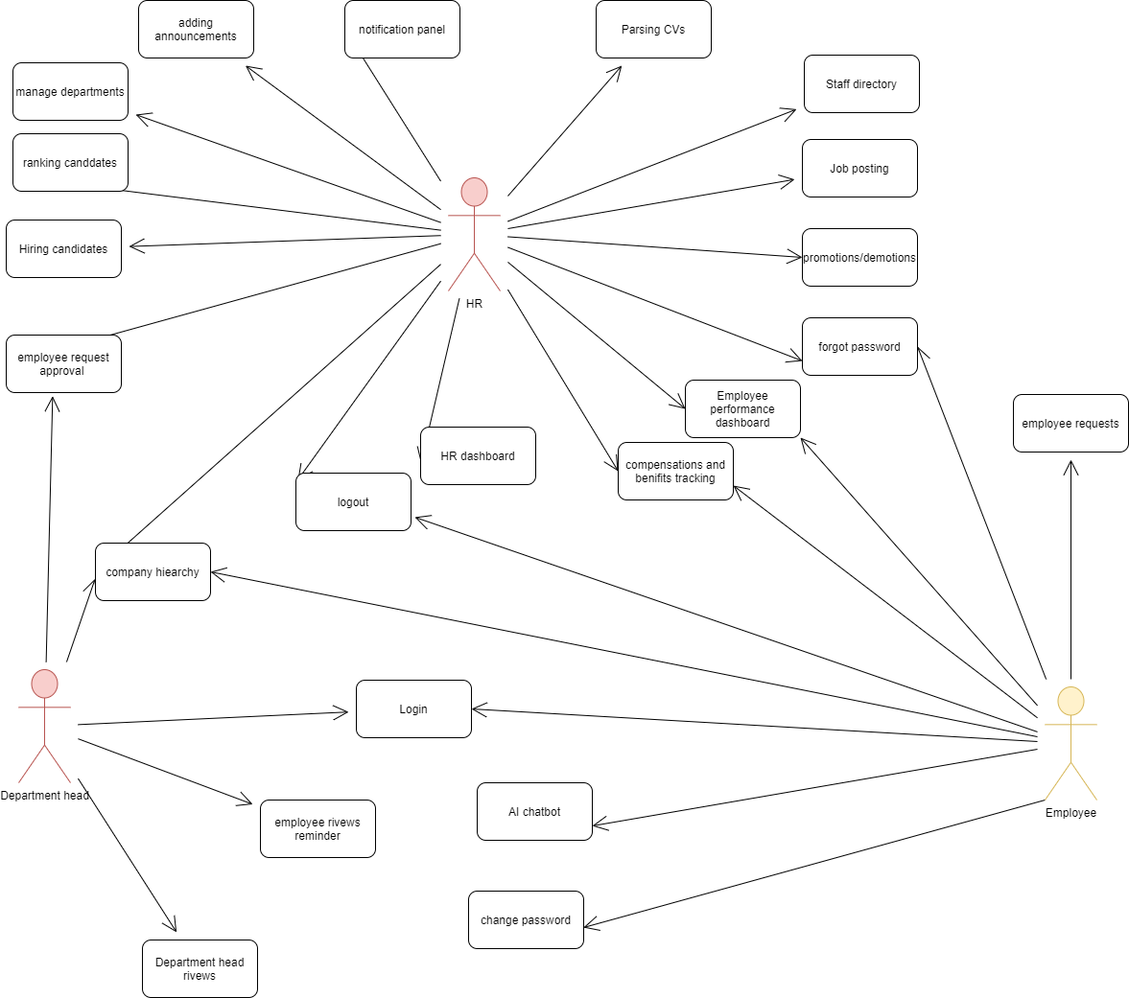

## Description of Use Cases

[Write use case description in a way that the roles of actor and the system become clear at each step. Carefully look at the sample provided in the template.

In general, there are issues with overall content including pre and post conditions, format of description and alternative paths. See my comments in some selected use cases below for specific examples.]

### 3.2.1 Login

| **Identifier** | | UC-001 | |
| --- | --- | --- | --- |
| **Purpose** | | A registered user login to system to access the functionality of system | |
| **Pre-conditions** | | A user must have an account and the system must be connected to the network. | |
| **Post-conditions** | | The user must be authorized to use the system. | |
|  | | | |
| **Step #** | **Typical Course of Action** | |
| **1.** | User Enters their username & their password [It should be clear who is performing this action: user or system] | |
| **2.** | The Username and password are validated by the system. [who is validating?] | |
| **3.** | User is allowed access to system | |
|  | | | |
| **Step #** | **Alternate Courses of Action** | |
| **1.** | In step 1, if the username or password is invalid, the system shows an error message | |
| **Step #** | **Exception Paths** | |
|  | None | |

### 

### 3.2.2 Logout

| **Identifier** | | UC-002 | |
| --- | --- | --- | --- |
| **Purpose** | | User log off from the system | |
| **Pre-conditions** | | User must be logged in | |
| **Post-conditions** | | The user is logged out of the system | |
|  | | | |
| **Step #** | **Typical Course of Action** | |
| **1.** | User clicks on the logout button and clicks confirm | |
|  | | | |
| **Step #** | **Alternate Courses of Action** | |
| **1.** |  | |
| **Step #** | **Exception Paths** | |
| **1.** | None. [Why is it an exception in logout use case?] | |

### 3.2.3 Forgot Password

| **Identifier** | | UC-003 | |
| --- | --- | --- | --- |
| **Purpose** | | A registered user trying to get a new password. | |
| **Pre-conditions** | | A user must have an account. | |
| **Post-conditions** | | Password will be changed | |
|  | | | |
| **Step #** | **Typical Course of Action** | |
| **1.** | Enter Username | |
| **2.** | Enter password | |
| **3.** | Validate Username through email. | |
| **4.** | Reset password | |
| **5.** | System will let the user know that their password has been changed. | |
|  | | | |
| **Step #** | **Alternate Courses of Action** | |
| **1.** | None | |
| **Step #** | **Exception Paths** | |
| **1.** | If an invalid username is entered, the system shows an error message | |

### 3.2.4 Job Promotions/Demotions

| **Identifier** | | UC-004 | |
| --- | --- | --- | --- |
| **Purpose** | | The HR manager wants to update the position/rank of an employee | |
| **Pre-conditions** | | The HR manager manager must be logged in | |
| **Post-conditions** | | The employee is promoted or demoted. [This is not a post-condition] | |
|  | | | |
| **Step #** | **Typical Course of Action** | |
| **1.** | HR manager clicks manage employees on the HR portal | |
| **2.** | A list of all employees will be presented to the HR manager | |
| **3.** | HR manager will select the employee | |
| **4.** | The profile of the employee will open up and the HR manager will be able to change/edit the information of the employee. | |
|  | | | |
| **Step #** | **Alternate Courses of Action** | |
| **1.** | HR manager clicks manage employees on the HR dashboard | |
| **2.** | A list of all employees will be presented to the HR manager | |
| **3.** | HR manager will search for the name of the employee | |
| **4.** | HR manager will select the employee | |
| **5.** | The profile of the employee will open up and the HR manager will be able to change/edit the information of the employee. | |
| **Step #** | **Exception Paths** | |
|  | None | |

### 3.2.5 HR Dashboard

| **Identifier** | | UC-005 | |
| --- | --- | --- | --- |
| **Purpose** | | To provide an overview of the company and serve and give access to HR’s functionality | |
| **Pre-conditions** | | The HR manager manager must have logged in | |
| **Post-conditions** | | The overview is provided | |
|  | | | |
| **Step #** | **Typical Course of Action** | |
| **1.** | The HR staff goes to the website home page | |
| **2.** | The homepage requests their id and password | |
| **3.** | The user enters the information | |
| **4.** | The system loads the users home page | |
| **5.** | The user goes to their profile | |
| **6.** | The user selects the HR dashboard option | |
| **7.** | If the user has access, the Dashboard containing company information and HR functionality will show up | |
| **8.** | The use case ends. | |
|  | | | |
| **Step #** | **Alternate Courses of Action** | |
| **1.** | None | |
|  |  | |
| **Step #** | **Exception Paths** | |
| **1.** | In step 7, if the user does not have access, then an error message is displayed | |

### 3.2.6 Hiring Candidates

| **Identifier** | | UC-006 | |
| --- | --- | --- | --- |
| **Purpose** | | Hiring candidates as employees and adding them to the system | |
| **Pre-conditions** | | The HR Manager must be logged into the hiring portal. [This is not a pre-condition] | |
| **Post-conditions** | | The candidate is hired and added as an employee. | |
|  | | | |
| **Step #** | **Typical Course of Action** | |
| **1.** | The HR manager retrieves the CV and data of the candidate by searching for it in the job postings list. | |
| **2.** | HR manager chooses the desired applicant by clicking Hire.[Isn’t there any search? ] | |
| **3.** | The candidate is added to the employee database | |
| **4.** | The use case ends. | |
|  | | | |
| **Step #** | **Alternate Courses of Action** | |
| **1.** | None[At which step does it happen in the typical course of action? What does it mean to say “wait for more resumes” for the system?] | |
| **Step #** | **Exception Paths** | |
| **1.** | None | |

### 

### 3.2.7 Manage Departments

| **Identifier** | | | UC-007 | |
| --- | --- | --- | --- | --- |
| **Purpose** | | | To add or remove departments or employees from the database | |
| **Pre-conditions** | | | The user must be logged in from their HR account. | |
| **Post-conditions** | | | Departments or employees will be added/removed | |
|  | | | | |
| **Step #** |  | **Typical Course of Action** | |
| **1.** |  | The user goes to the manage departments option | |
| **2.** |  | The user clicks add or remove department [After this user action, the system’s response should be mentioned in the next step. Same comment applies to many use cases.] | |
| **3.** |  | The system displays a drop down menu where they can either add a new department or add an employee to a specific department | |
| **4.** |  | The user clicks on the department that they want to add an employee to | |
| **5.** |  | The user enters the information of the employee | |
| **6.** |  | The user clicks add | |
| **7.** |  | Dept Head receives a notification after the database has been updated. | |
| **8.** |  | The use case ends | |
| **Step #** |  | **Alternate Courses of Action** | |
| **1.** |  | After step 2, the user can choose to add a new department. [what will be the flow in this case?] | |
| **2.** |  | The user clicks the ‘add button’ | |
| **3.** |  | A new department is added to the system | |
| **Step #** |  | **Exception Paths** | |
| **1.** |  | None | |

### 3.2.8 Change Password

| **Identifier** | | UC-008 | |
| --- | --- | --- | --- |
| **Purpose** | | The user goes to their profile to change their password | |
| **Pre-conditions** | | The user has logged into their account successfully | |
| **Post-conditions** | | The password is changed in the system | |
|  | | | |
| **Step #** | **Typical Course of Action** | |
|  | The user goes to their profile | |
|  | The user selects the change password option | |
|  | The user confirms their new password | |
|  | If the user has successfully entered the new password twice, their new password is entered into the system and can be used to log-in in the future. | |
|  | The use case ends. | |
|  |  | |
| **Step #** | **Alternate Courses of Action** | |
|  | None | |
| **Step #** | **Exception Paths** | |
|  | In step 7, if the passwords don’t match, then an error message is displayed and the user is asked to re-enter the passwords. | |

### 3.2.9 Parsing CVs

### 

| **Identifier** | | UC-009 | |
| --- | --- | --- | --- |
| **Purpose** | | Parsing CV for shortlisting of suitable candidates | |
| **Pre-conditions** | | The CV’s of candidates are in proper format | |
| **Post-conditions** | | The parsed CV’s are then filtered | |
|  | | | |
| **Step #** | **Typical Course of Action** | |
| **1.** | The candidate uploads the cv in the job posting | |
| **2.** | The system will extract info from the CV | |
| **3.** | They are then parsed according to the relevant job descriptions. | |
| **4.** | The use case ends. | |
|  | | | |
| **Step #** | **Alternate Courses of Action** | |
| **1.** | None | |
| **Step #** | **Exception Paths** | |
| **1.** | None | |

### 3.2.10 Compensation and Benefits tracking

| **Identifier** | | UC-010 | |
| --- | --- | --- | --- |
| **Purpose** | | For the HR manager to update the compensation and benefits of employees | |
| **Pre-conditions** | | The HR manager has their dashboard opened. | |
| **Post-conditions** | | Compensation/benefits have been updated | |
|  | | | |
| **Step #** | **Typical Course of Action** | |
| **1.** | The HR manager will navigate to the compensation and benefits section from their dashboard. | |
| **2.** | The manager will then search for the employee | |
| **3.** | They will then update the employee’s benefits/compensation in the employee's lifetime. | |
| **4.** | The use case ends. | |
|  |  | |
|  | | | |
| **Step #** | **Alternate Courses of Action** | |
| **1.** |  | |
| **Step #** | **Exception Paths** | |
| **1.** | None | |

### 3.2.11 Staff directory

| **Identifier** | | UC-011 | |
| --- | --- | --- | --- |
| **Purpose** | | For the HR manager to search for employees through filtering (by name, department , skills , education and project names they have done) | |
| **Pre-conditions** | | The HR manager has logged in. | |
| **Post-conditions** | | Employee profile can be selected | |
|  | | | |
| **Step #** | **Typical Course of Action** | |
| **1.** | The user will navigate to the search option in their dashboard. | |
| **2.** | The user can search by name & select any of the filters | |
| **3.** | The user will then select the employee whose profile they want to visit | |
| **4.** | Their profile is displayed | |
| **5.** | The use case ends | |
|  |  | |
| **Step #** | **Alternate Courses of Action** | |
| 1 | In step 2, the user can choose to not select any filters (and not enter a name). Instead they may scroll down the employee list (arranged alphabetically) | |
| **Step #** | **Exception Paths** | |
| 1 | In step 3, if the user does not have access to the employee’s profile, an error message will be displayed | |

### 3.2.12 Employee requests

| **Identifier** | | UC-012 | |
| --- | --- | --- | --- |
| **Purpose** | | Employees can apply for sick days, personal days, vacation days, and volunteer hours | |
| **Pre-conditions** | | The employee must be logged in and should be on the dashboard screen | |
| **Post-conditions** | | A request is sent to the manager/head of the team for approval | |
|  | | | |
| **Step #** | **Typical Course of Action** | |
|  | The user goes to the website home page | |
|  | The homepage requests their id and password | |
|  | The user enters the information | |
|  | The system loads the users home page | |
| **5.** | The user clicks on the ‘employee requests’ option | |
| **6.** | The user clicks on the apply for leave option | |
| **7.** | A calendar pops up and the employee selects a start date | |
| **8.** | The employee then selects an end date | |
| **9.** | The employee adds their reasoning in a text box | |
| **10.** | The employee clicks send and the application is sent to the department head | |
| **11.** | The use case ends | |
|  | | | |
| **Step #** | **Alternate Courses of Action** | |
|  | In step 6, the employee will have a variety of other options (sick days, personal days, vacation days, and volunteer hours) | |
| **Step #** | **Exception Paths** | |
| **1.** | If the starting/ending date is not selected or a date from the past is selected the application will not be sent and an error message will be shown | |

### 

### 3.2.13 Employee reviews

| **Identifier** | | UC-013 | |
| --- | --- | --- | --- |
| **Purpose** | | For employee reviews to be added to their record . | |
| **Pre-conditions** | | The Immediate Manager must be logged in with their account and must be authorized to give reviews. | |
| **Post-conditions** | | Reviews for employees will be visible on the HR dashboard. | |
|  | | | |
| **Step #** | **Typical Course of Action** | |
| **1.** | The user selects an employee from their department | |
| **2.** | The user clicks on the ‘employee review’ option | |
| **3.** | The user is taken to a new screen with the previous reviews. | |
| **4.** | The user can wish to edit old reviews or add new ones | |
| **5.** | The use case ends. | |
|  | | | |
| **Step #** | **Alternate Courses of Action** | |
| **1.** | None | |
| **Step #** | **Exception Paths** | |
| **1.** | In step 3, if the user does not have the authority to edit the employee’s review, an error message will be shown | |

### 

### 3.2.14 Employee performance analytics dashboard

| **Identifier** | | UC-014 | |
| --- | --- | --- | --- |
| **Purpose** | | For users to see the performance analytics of themselves or others. | |
| **Pre-conditions** | | The user should be logged in and have access to the performance analytics of the individual whose dashboard they wish to see | |
| **Post-conditions** | | The dashboard is displayed with all relevant statistics | |
|  | | | |
| **Step #** | **Typical Course of Action** | |
|  | The user clicks on the performance analytics option | |
|  | The user is asked to enter the ID of the employee whose performance analytics they wish to see | |
|  | The system determines if the user has access to the analytics of the particular individual | |
|  | If the user has access, the dashboard is displayed. | |
|  | The use case ends. | |
| **Step #** | **Alternate Courses of Action** | |
| **1.** | In step 6, the customer can cancel the transaction and go directly to step 9. | |
| **Step #** | **Exception Paths** | |
|  | In step 7, if the user does not have access, then an error message is displayed and execution proceeds to step 9. | |

### 3.2.15 Adding announcements

| **Identifier** | | UC-015 | |
| --- | --- | --- | --- |
| **Purpose** | | For HR to add announcements to the notification panel of employees / department heads. | |
| **Pre-conditions** | | The user should be logged in from their HR account | |
| **Post-conditions** | | The announcement is posted | |
|  | | | |
| **Step #** | **Typical Course of Action** | |
| **1.** | The user goes to the announcements option | |
| **2.** | The user clicks on add announcement | |
| **3.** | The user enters the message to be posted | |
| **4.** | The use case ends. | |
|  | | | |
| **Step #** | **Alternate Courses of Action** | |
| **1.** | None | |
| **Step #** | **Exception Paths** | |
| **1.** | None | |

### 3.2.16 Notification panel

| **Identifier** | | UC-016 | |
| --- | --- | --- | --- |
| **Purpose** | | For users to be able to read recent news and announcements (e.g., about new HR policies or request approval / rejection) | |
| **Pre-conditions** | | User must be logged in | |
| **Post-conditions** | | Recent news and announcements are displayed | |
|  | | | |
| **Step #** | **Typical Course of Action** | |
| **1.** | User must click on the notification panel on the top right | |
| **2.** | The recent announcements are displayed | |
| **3.** | The user clicks on an announcement of their choice | |
| **4.** | The announcement is fully shown on a seperate screen | |
| **5.** | The use case ends. | |
|  | | | |
| **Step #** | **Alternate Courses of Action** | |
| **1.** | After step 2, the user can decide to move straight to step 5.. | |
| **Step #** | **Exception Paths** | |
| **1.** | After step 1, if there are no new announcements, then the user moves to step 5 | |

### 3.2.17 Employee request approval/denial

| **Identifier** | | UC-017 | |
| --- | --- | --- | --- |
| **Purpose** | | For manager to approve or deny employee requests regarding sick days, personal days, vacation days, and volunteer hours | |
| **Pre-conditions** | | User must be logged with their department head account | |
| **Post-conditions** | | Request will be approved or denied | |
|  | | | |
| **Step #** | **Typical Course of Action** | |
| **1.** | Users must click on the notification panel. | |
| **2.** | The recent announcements are displayed. | |
| **3.** | The user clicks on an announcement regarding employee request | |
| **4.** | The user clicks either accept or reject | |
| **5.** | The result is forwarded to the employee’s notification panel | |
| **6.** | The use case ends | |
|  | | | |
| **Step #** | **Alternate Courses of Action** | |
| **1.** | After step 4, the user can decide to ignore the request. | |
| **Step #** | **Exception Paths** | |
| **1.** | After step 1, if there are no new announcements, then the user moves to step 5 | |

### 3.2.18 Employee reviews reminder

| **Identifier** | | UC-018 | |
| --- | --- | --- | --- |
| **Purpose** | | To act as a reminder for managers/department heads to add a performance review for their employee | |
| **Pre-conditions** | | User must be logged in with their department head account | |
| **Post-conditions** | | Employee Review section will be updates | |
|  | | | |
| **Step #** | **Typical Course of Action** | |
| **1.** | Users must click on the notification panel. | |
| **2.** | The recent announcements are displayed. | |
| **3.** | The user clicks on an announcement regarding employee performance review reminder | |
| **4.** | The user is taken to the employee profile where they can update the performance of the employee using KPIs. | |
| **5.** | The use case ends | |
|  | | | |
| **Step #** | **Alternate Courses of Action** | |
| **1.** | After step 2, the user can decide to ignore/delete the notification. | |
| **Step #** | **Exception Paths** | |
| **1.** | After step 1, if there are no new announcements, then the user moves to step 5 | |

### 3.2.19 Hierarchy Tree

| **Identifier** | | UC-019 | |
| --- | --- | --- | --- |
| **Purpose** | | To display information of the organization's hierarchy to the HR manager | |
| **Pre-conditions** | | The HR manager needs to be logged in | |
| **Post-conditions** | | The tree is displayed | |
|  | | | |
| **Step #** | **Typical Course of Action** | |
| **1.** | The HR manager clicks on the company hierarchy button | |
| **2.** | The organization's hierarchy is displayed. | |
| **3.** | The use case ends. | |
|  | | | |
| **Step #** | **Alternate Courses of Action** | |
| **1**. | None | |
| **Step #** | **Exception Paths** | |
| **1.** | None | |

### 3.2.20 Hiring portal/ Collecting CVs

| **Identifier** | | UC-020 | |
| --- | --- | --- | --- |
| **Purpose** | | To collect CVs and other information relevant to available jobs | |
| **Pre-conditions** | | User must be logged with their HR manager account | |
| **Post-conditions** | | User will have collected the CVs and other information | |
| **Step #** | **Typical Course of Action** | |
| **1.** | User must click on the hiring portal panel | |
| **2.** | The uploaded cvs are displayed | |
| **3.** | The use case ends | |
| **Step #** | **Alternate Courses of Action** | |
| **1.** | None | |
| **Step #** | **Exception Paths** | |
| **1.** | None | |

### 3.2.21 Job posting

| **Identifier** | | UC-021 | |
| --- | --- | --- | --- |
| **Purpose** | | To post available jobs on HR portal | |
| **Pre-conditions** | | User must be logged with their HR manager account | |
| **Post-conditions** | | Available jobs will be posted on HR portal | |
|  | | | |
| **Step #** | **Typical Course of Action** | |
| **1.** | User must click on the hiring portal panel | |
| **2.** | User must click on ‘add job’ | |
| **3.** | User must fill the information regarding requirements of job | |
| **4.** | User must click confirm | |
| **5.** | The use case ends | |
|  | | | |
| **Step #** | **Alternate Courses of Action** | |
| **1.** | None | |
| **Step #** | **Exception Paths** | |
| **1.** | None | |

### 3.2.22 AI chatbot - ‘Assistant’

| **Identifier** | | UC-022 | |
| --- | --- | --- | --- |
| **Purpose** | | To give employees access to an AI-powered assistant that answers employees’ common HR-related questions, and provide relevant documentation regarding their job | |
| **Pre-conditions** | | User must be logged in | |
| **Post-conditions** | | User’s query will be answered | |
|  | | | |
| **Step #** | **Typical Course of Action** | |
| **1.** | User must click on the ‘Assistant’ option | |
| **2.** | User must enter their question | |
| **3.** | If the chatbot has the answer to their question, it will display the answer | |
| **4.** | The use case ends | |
|  |  | |
|  | | | |
| **Step #** | **Alternate Courses of Action** | |
| **1.** | in step 3, if the chatbot does not have the answer to the question, it will ask the user to question the HR manager directly | |
| **Step #** | **Exception Paths** | |
| **1.** | None | |

# Class Diagram

## Description

This class diagram illustrates the relationships between the four classes of our system. The login class handles the login/logout process of all of our system's users. And it is the only class used by the rest of the classes. The HR Manager Class has functions to handle all functionalities. Similarly, the Department Head and Employee class have all the functionalities related to their respective actors.

## Diagram

[This is not really a class diagram of your system. There are applicants, CVs, notifications, announcements, user roles etc. in your system. You probably need to refresh concepts about class diagrams.]

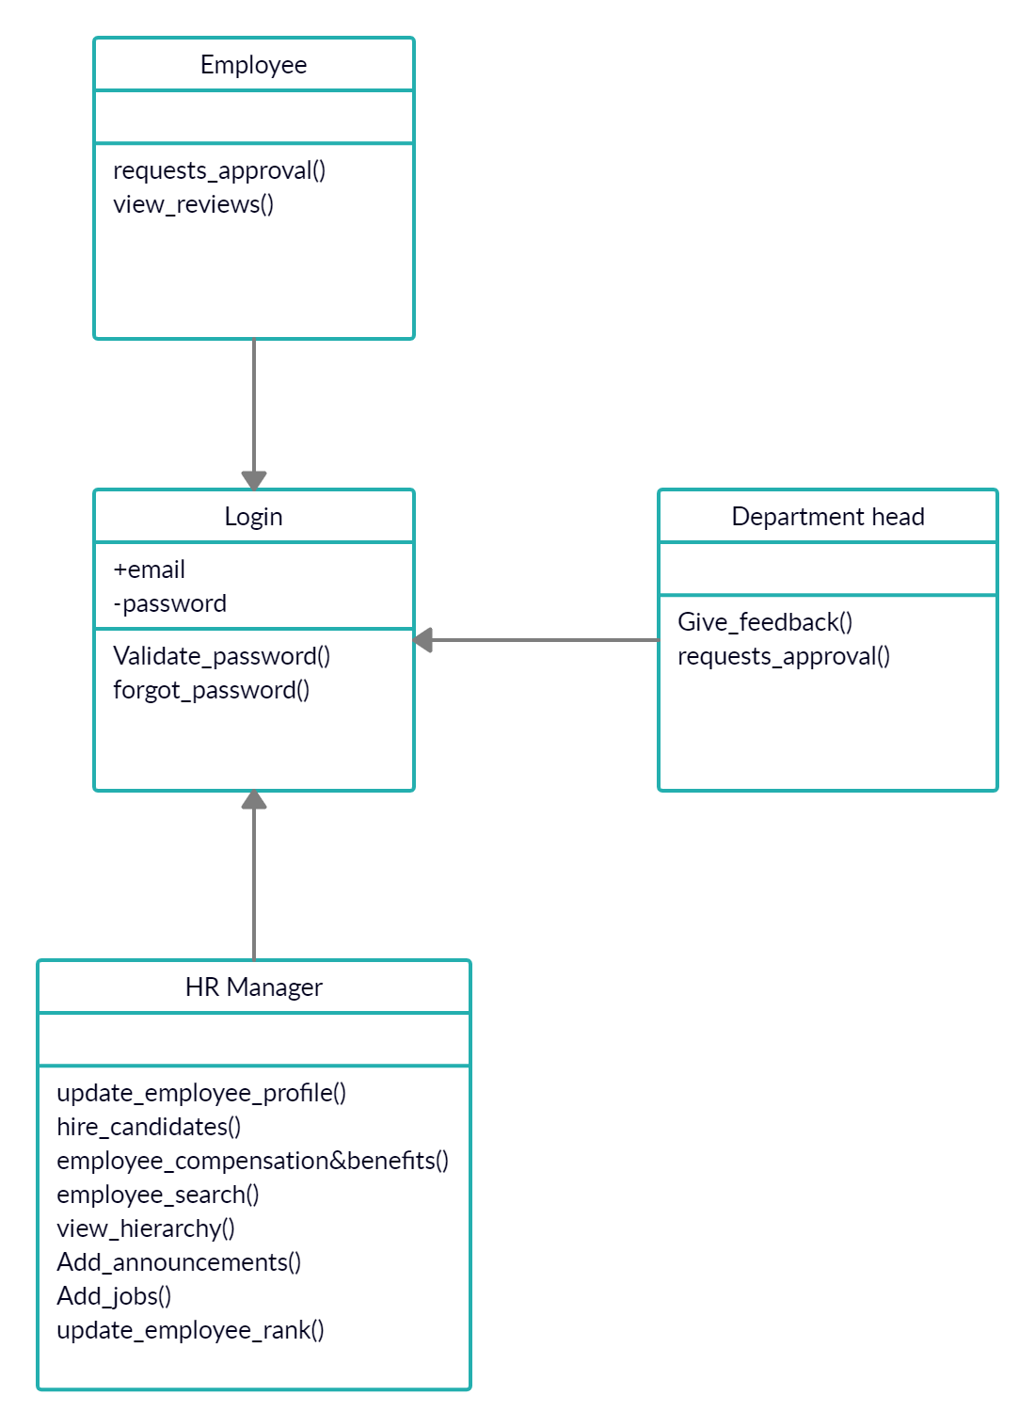

Revised Class Diagram:

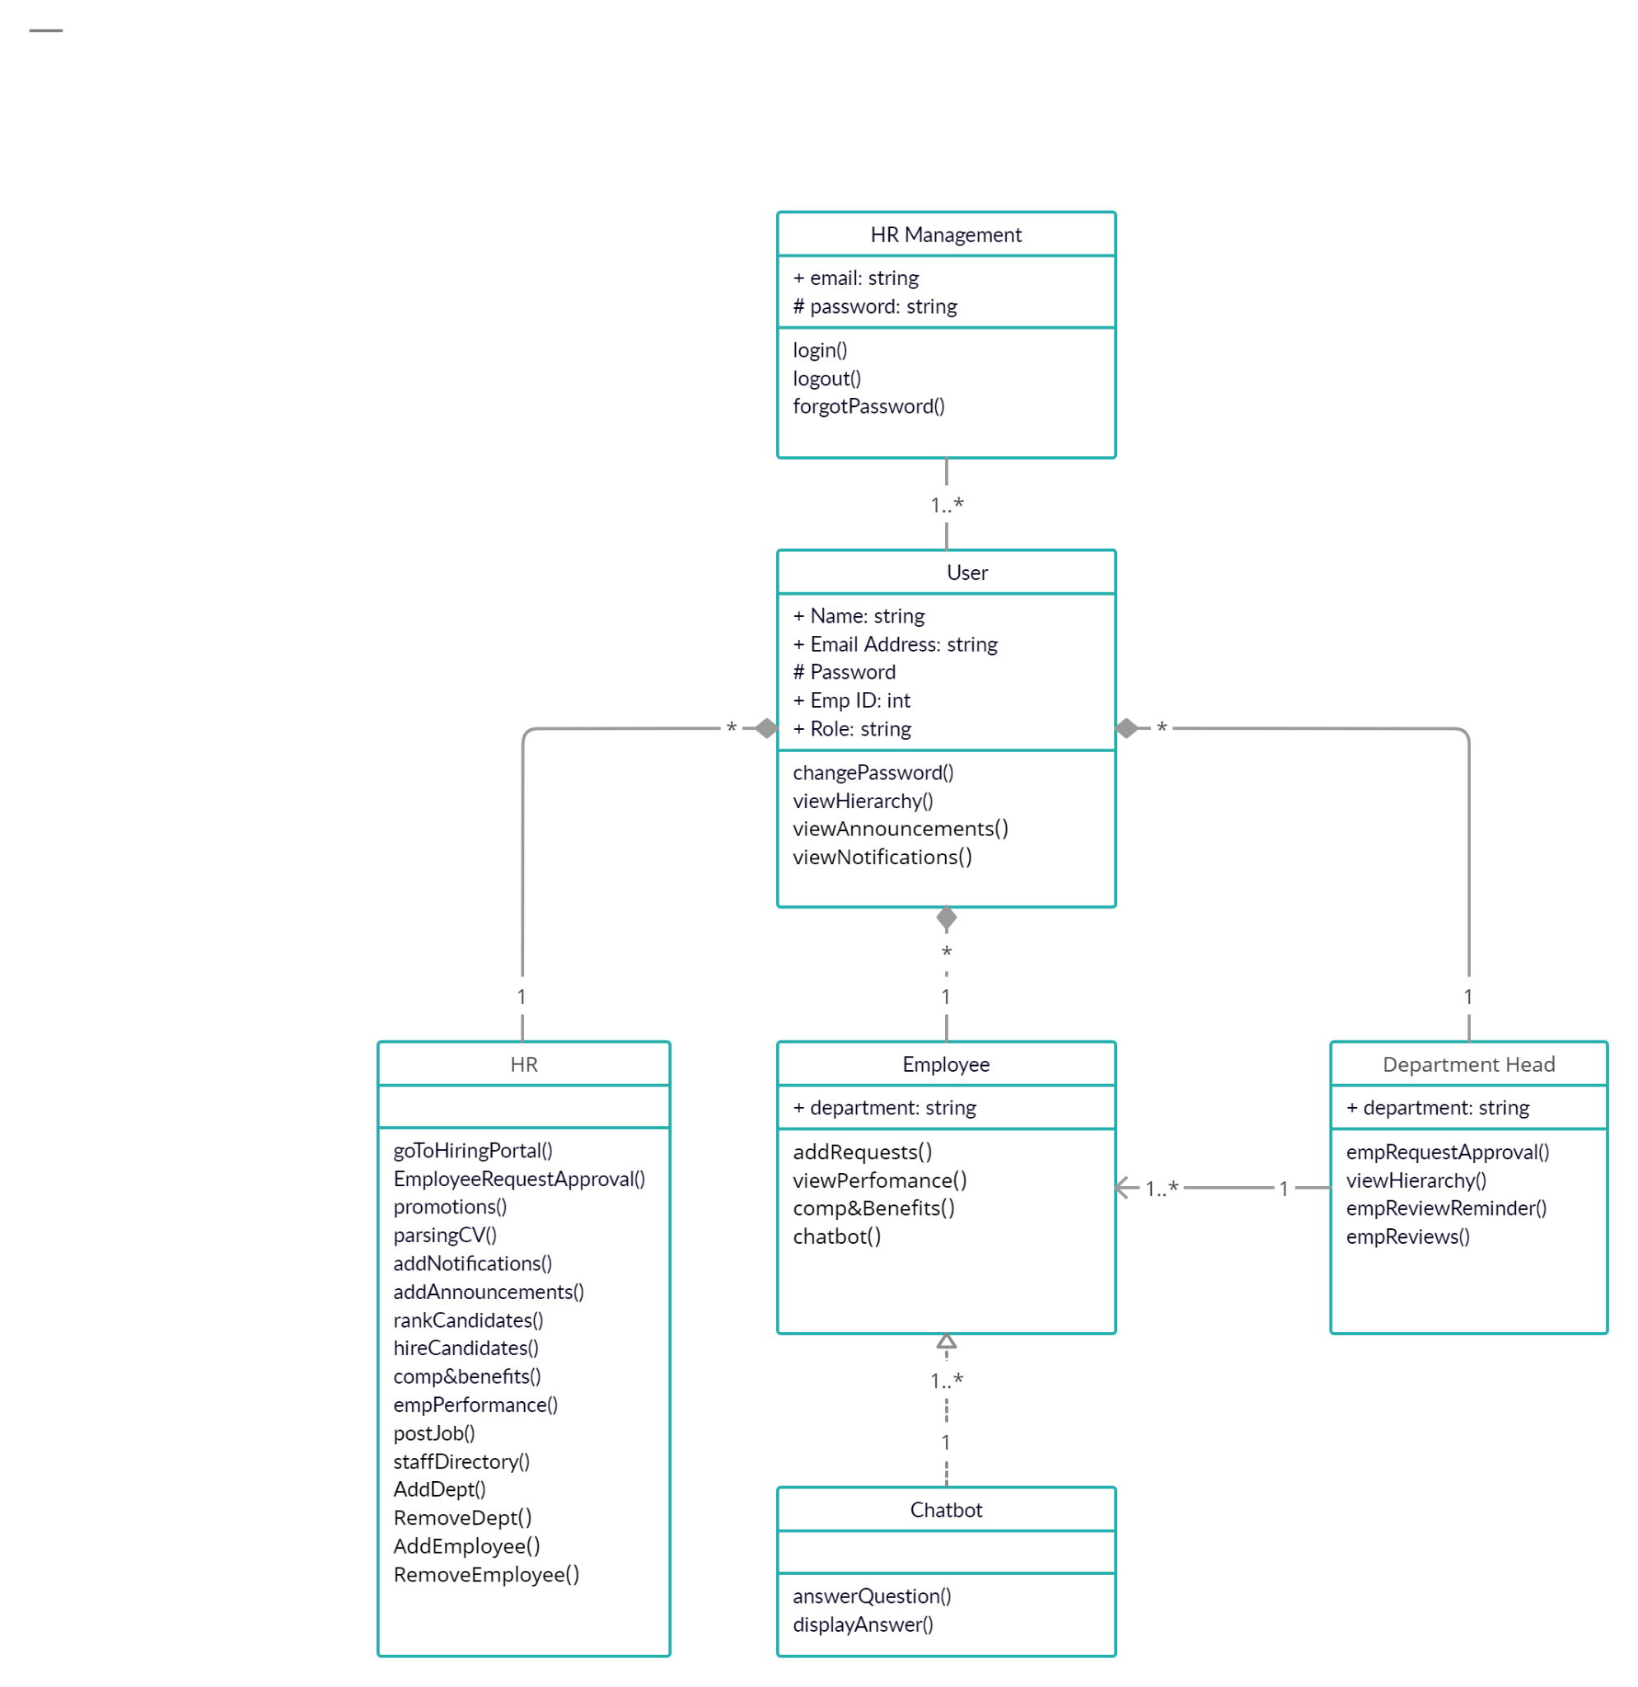

# Sequence Diagrams

[Some of the objects in sequence diagrams must be instances of the classes in your class diagram. First you should define your class diagram properly. The sequence diagrams that you have drawn right now show interaction among subsystems but not the classes.]

### 5.1 Login

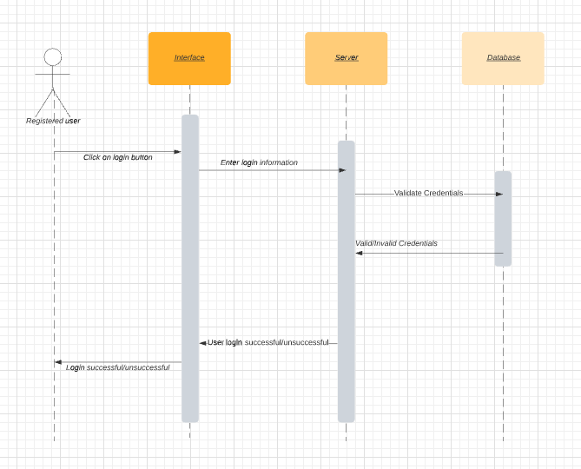

### 5.2 Logout

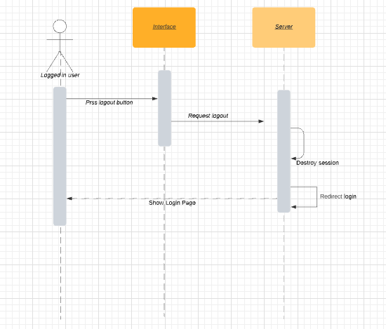

### 5.3 Change Password

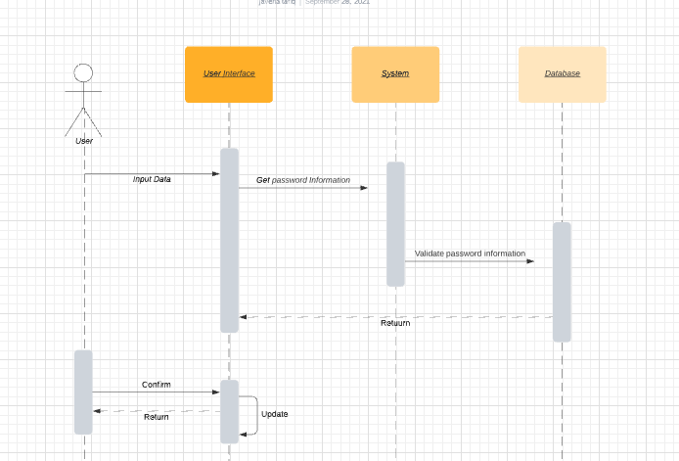

### 5.4 Forgot Password

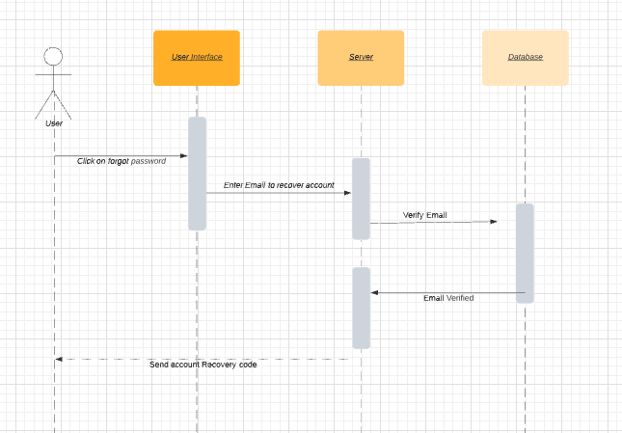

### 5.5 Job promotions/demotions

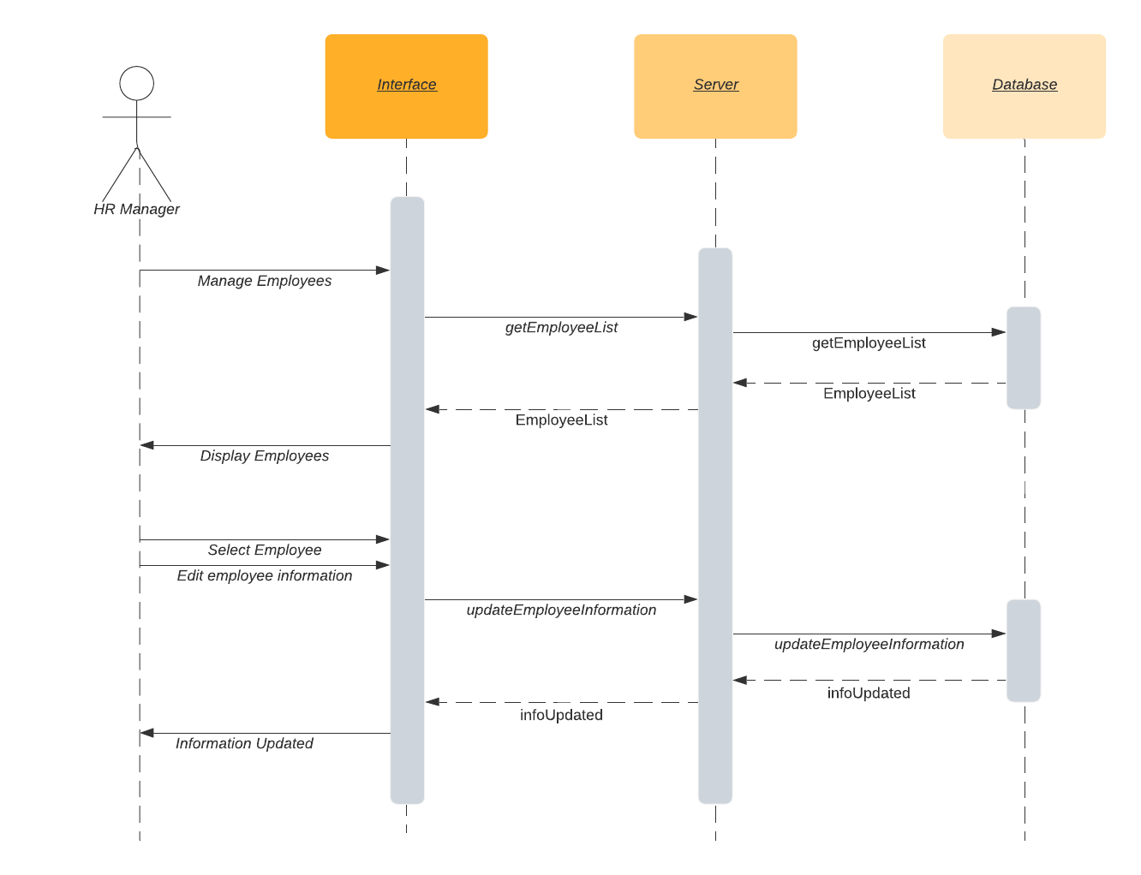

### 5.6 HR Dashboard

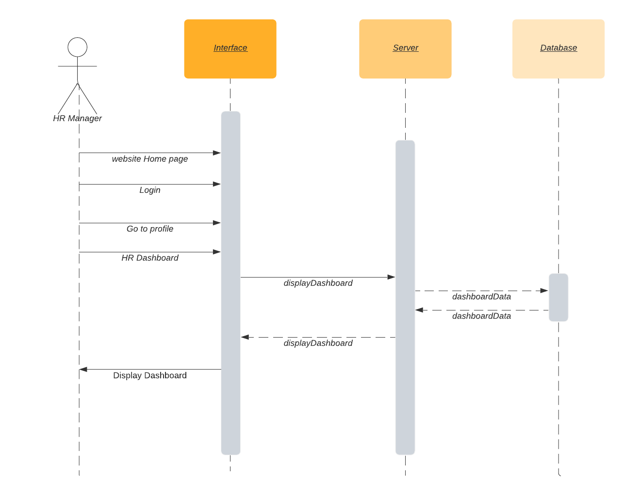

### 5.7 Manage Departments

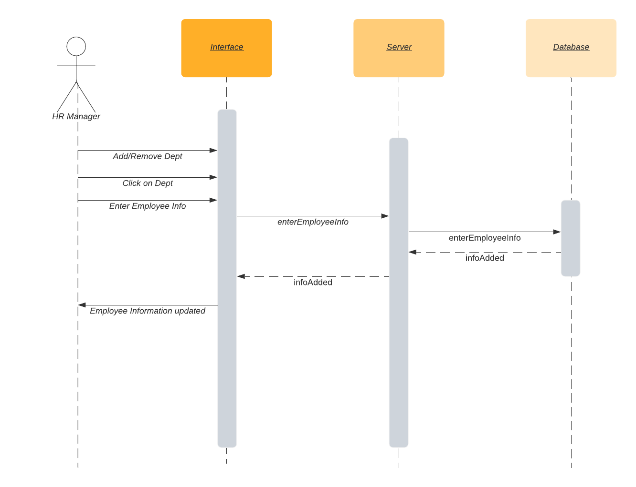

### 5.8 Parsing CV’s

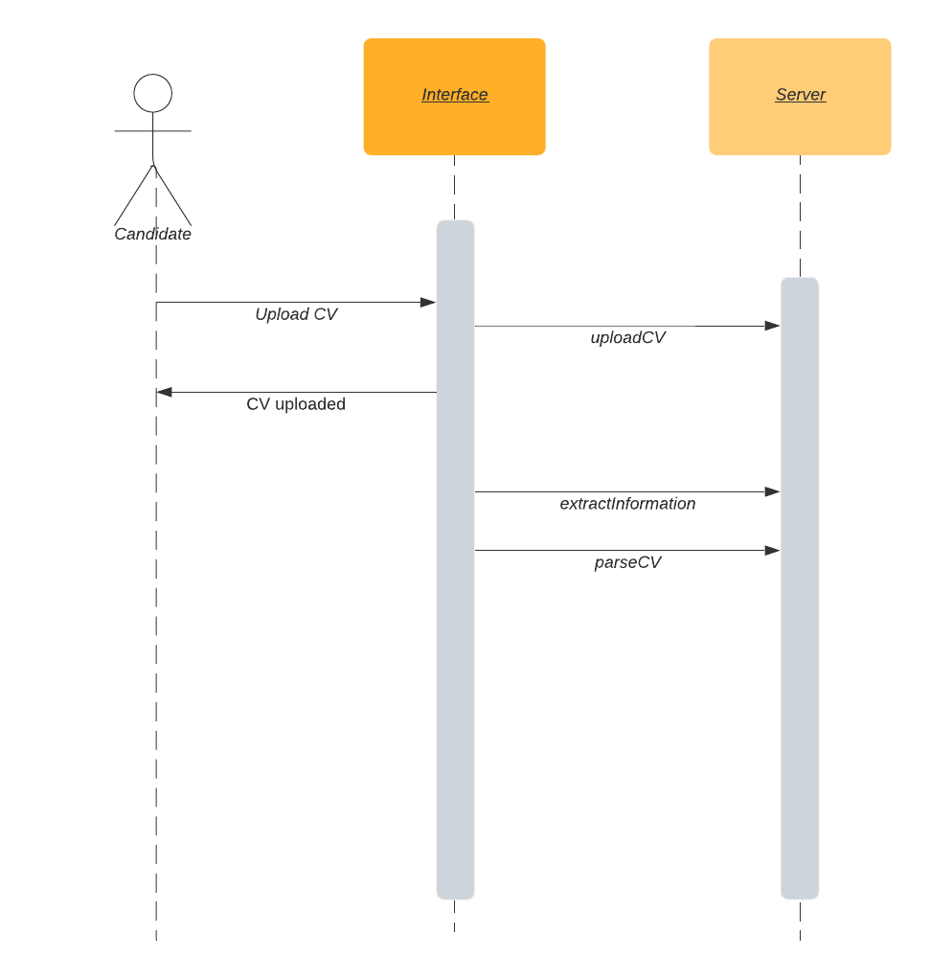

### 5.9 Compensation and Benefits tracking

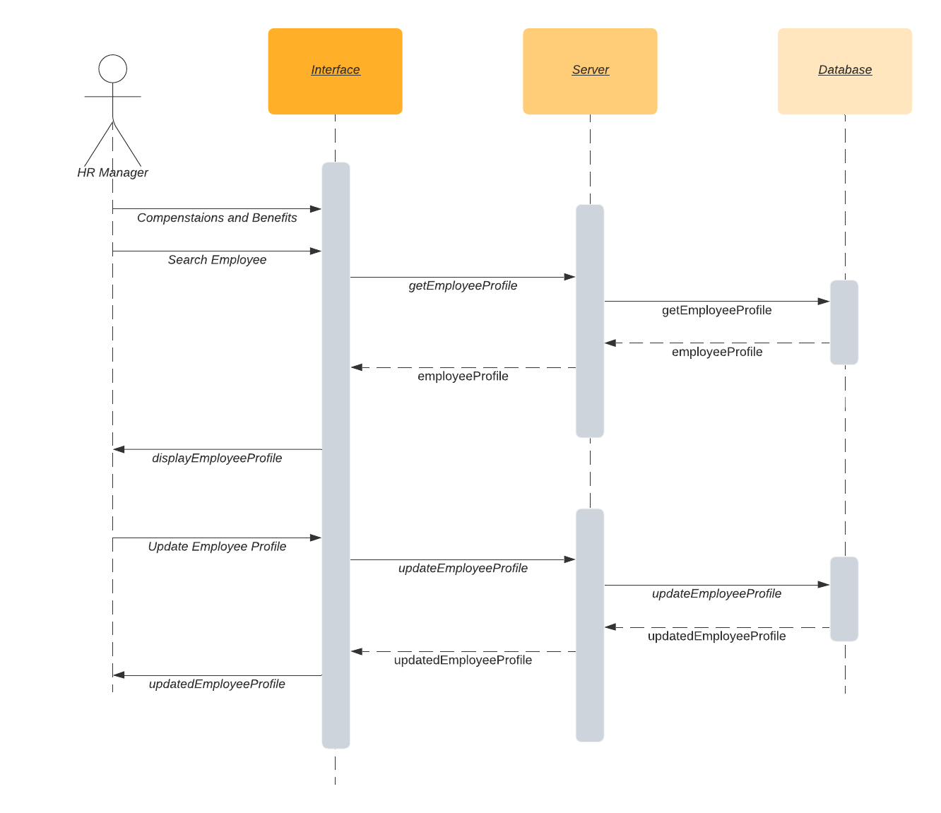

### 5.10 Hierarchy Tree

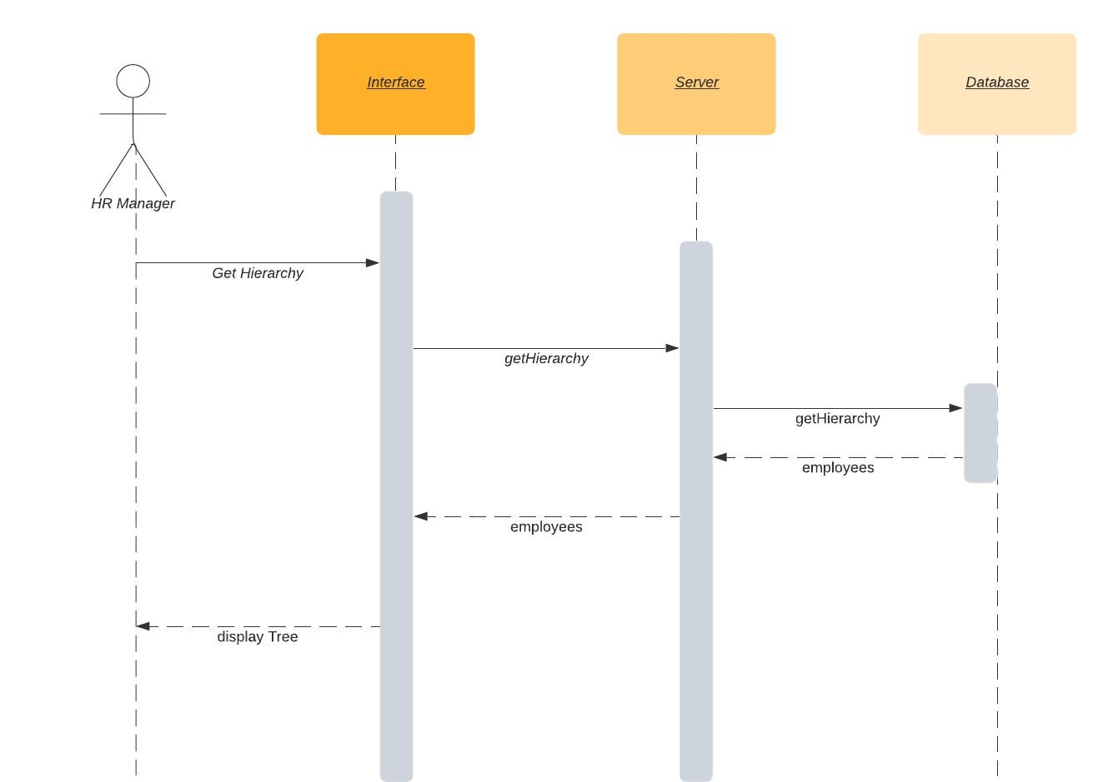

### 5.11 Job Posting

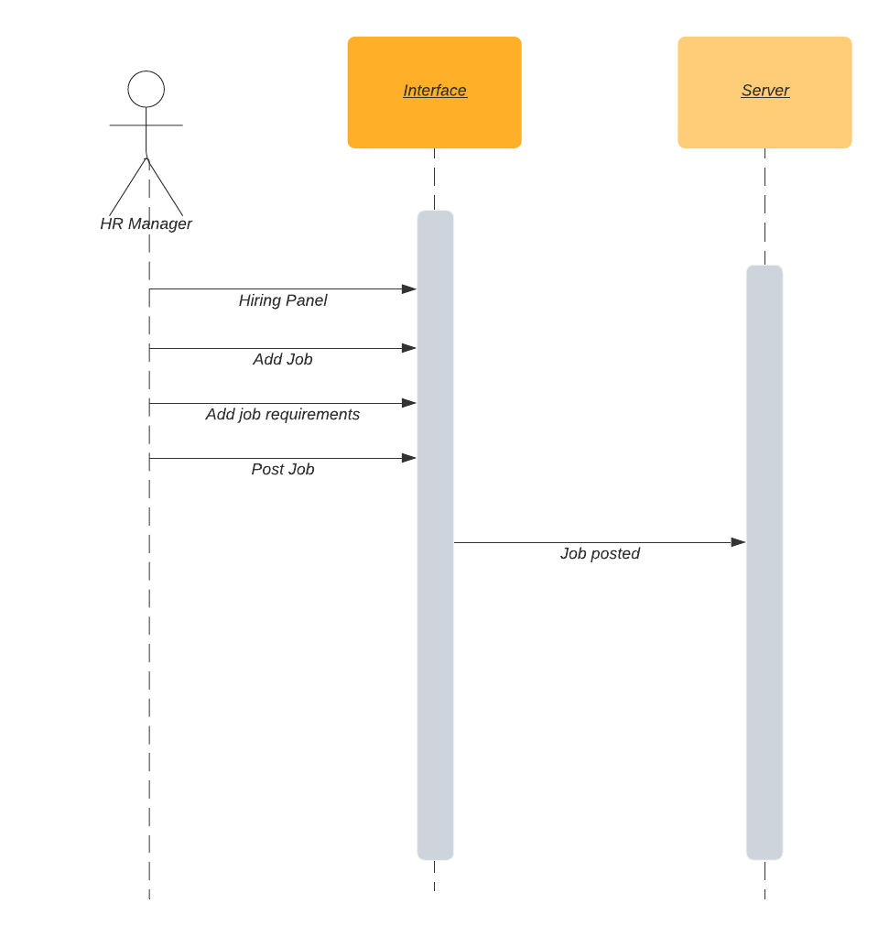

### 5.12 Adding Announcements:

### 5.13 Employee Data Analytics:

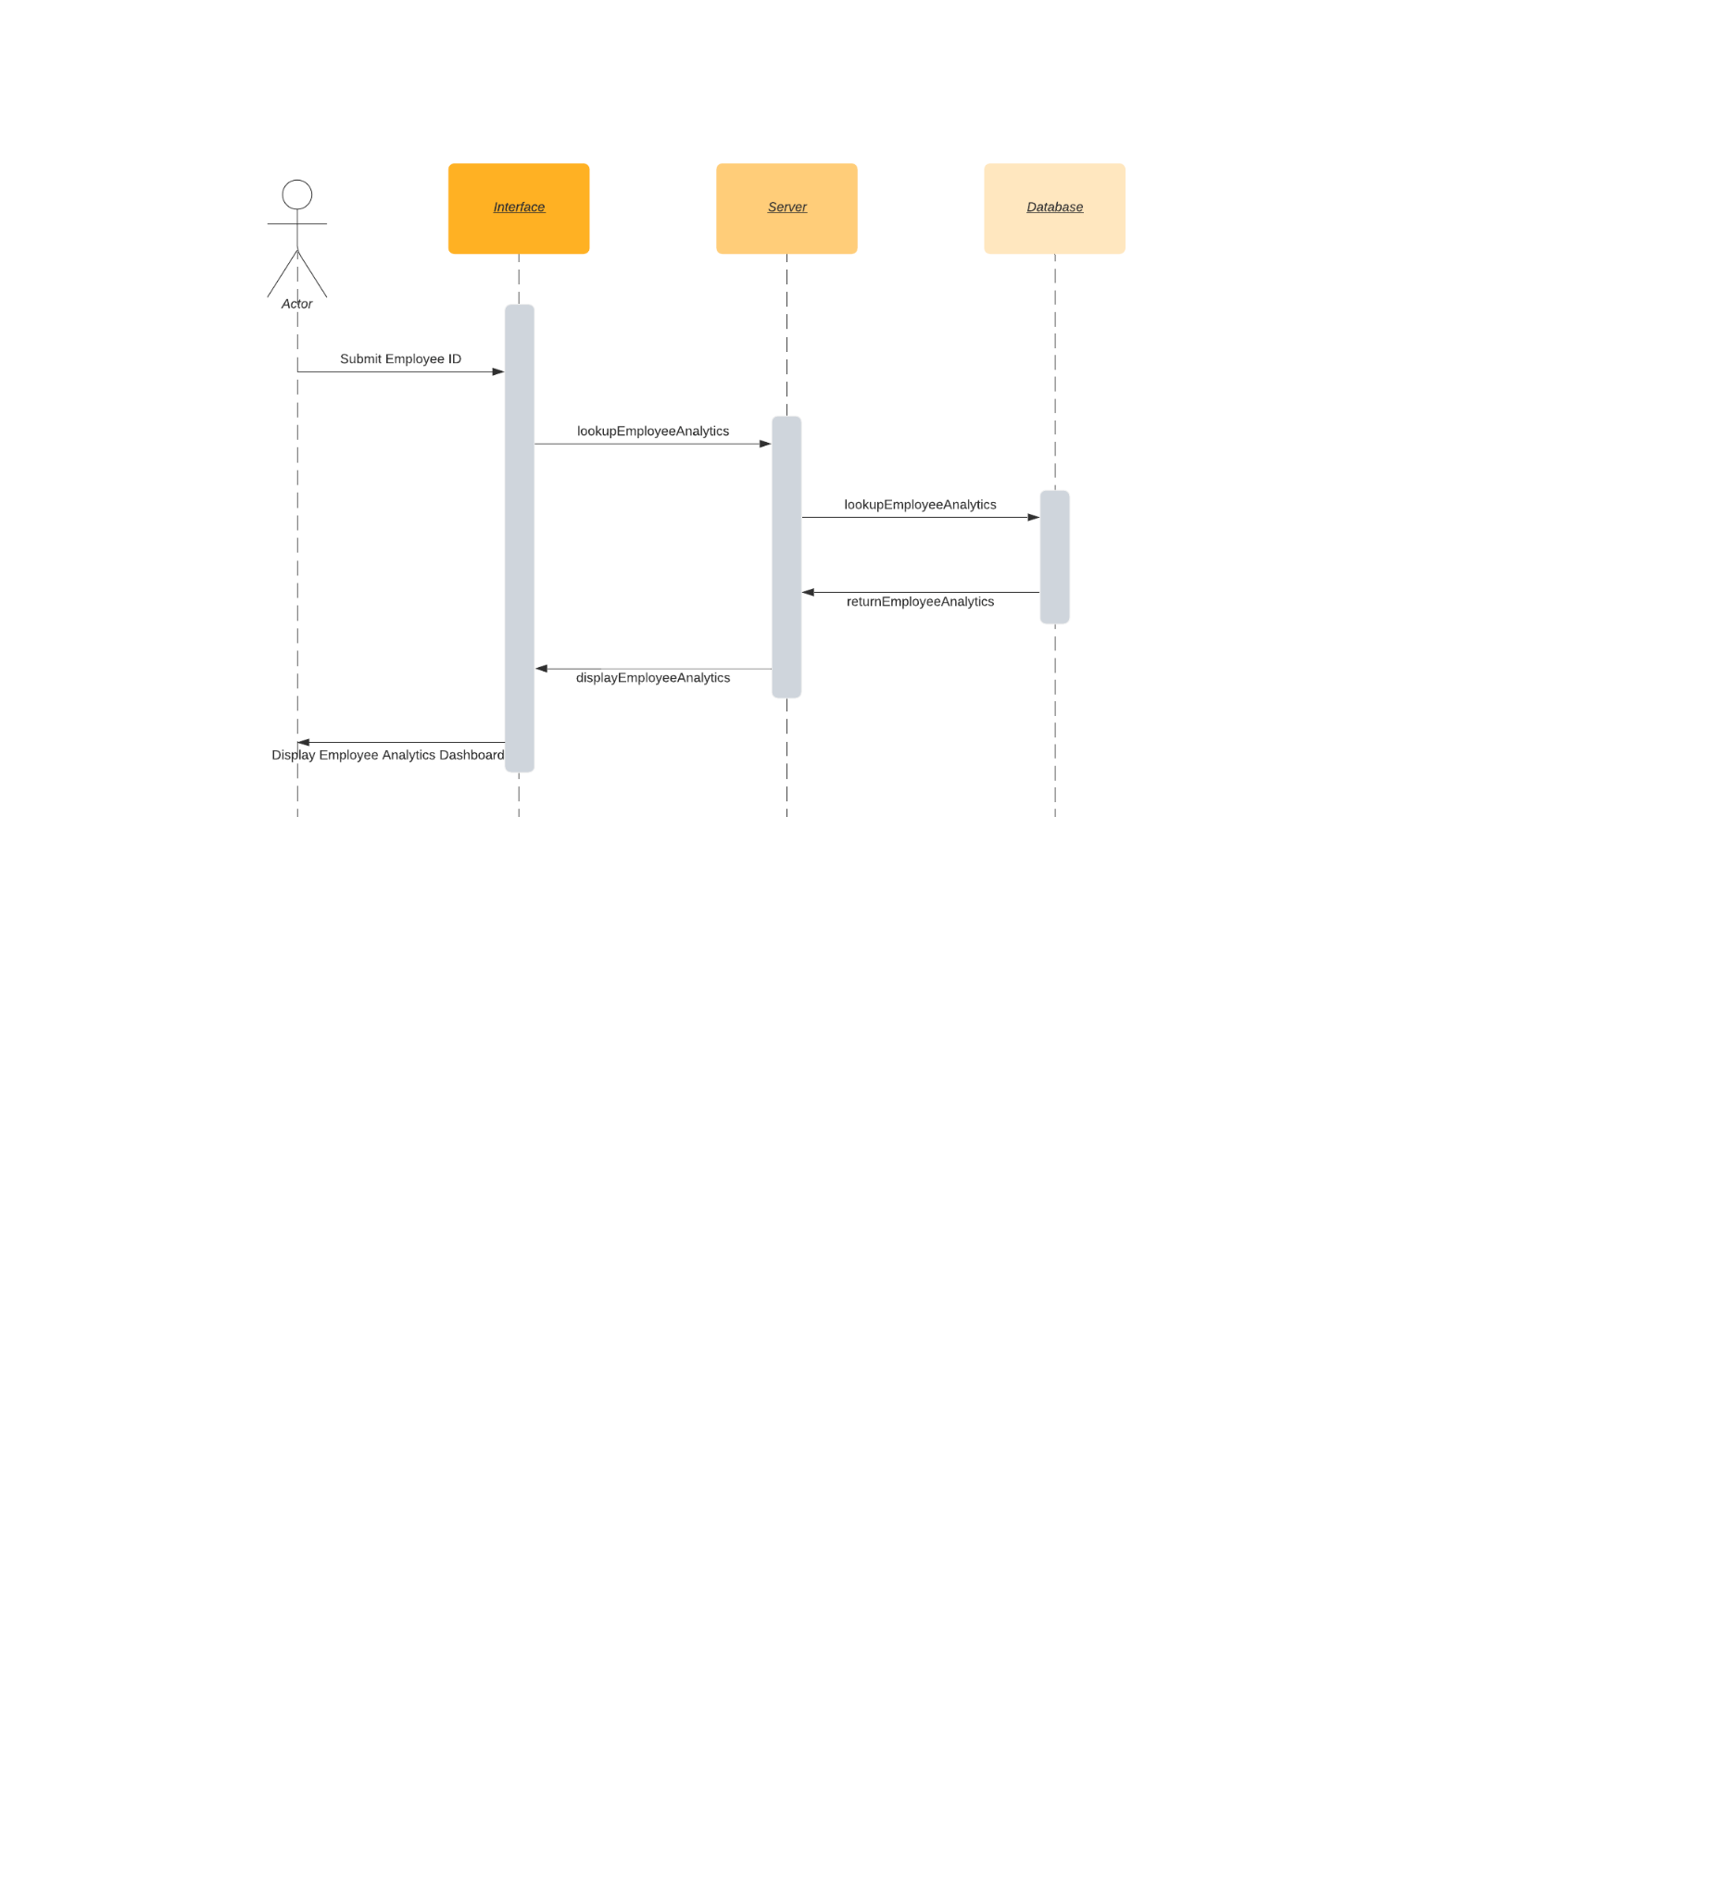

### 5.14 Employee Requests:

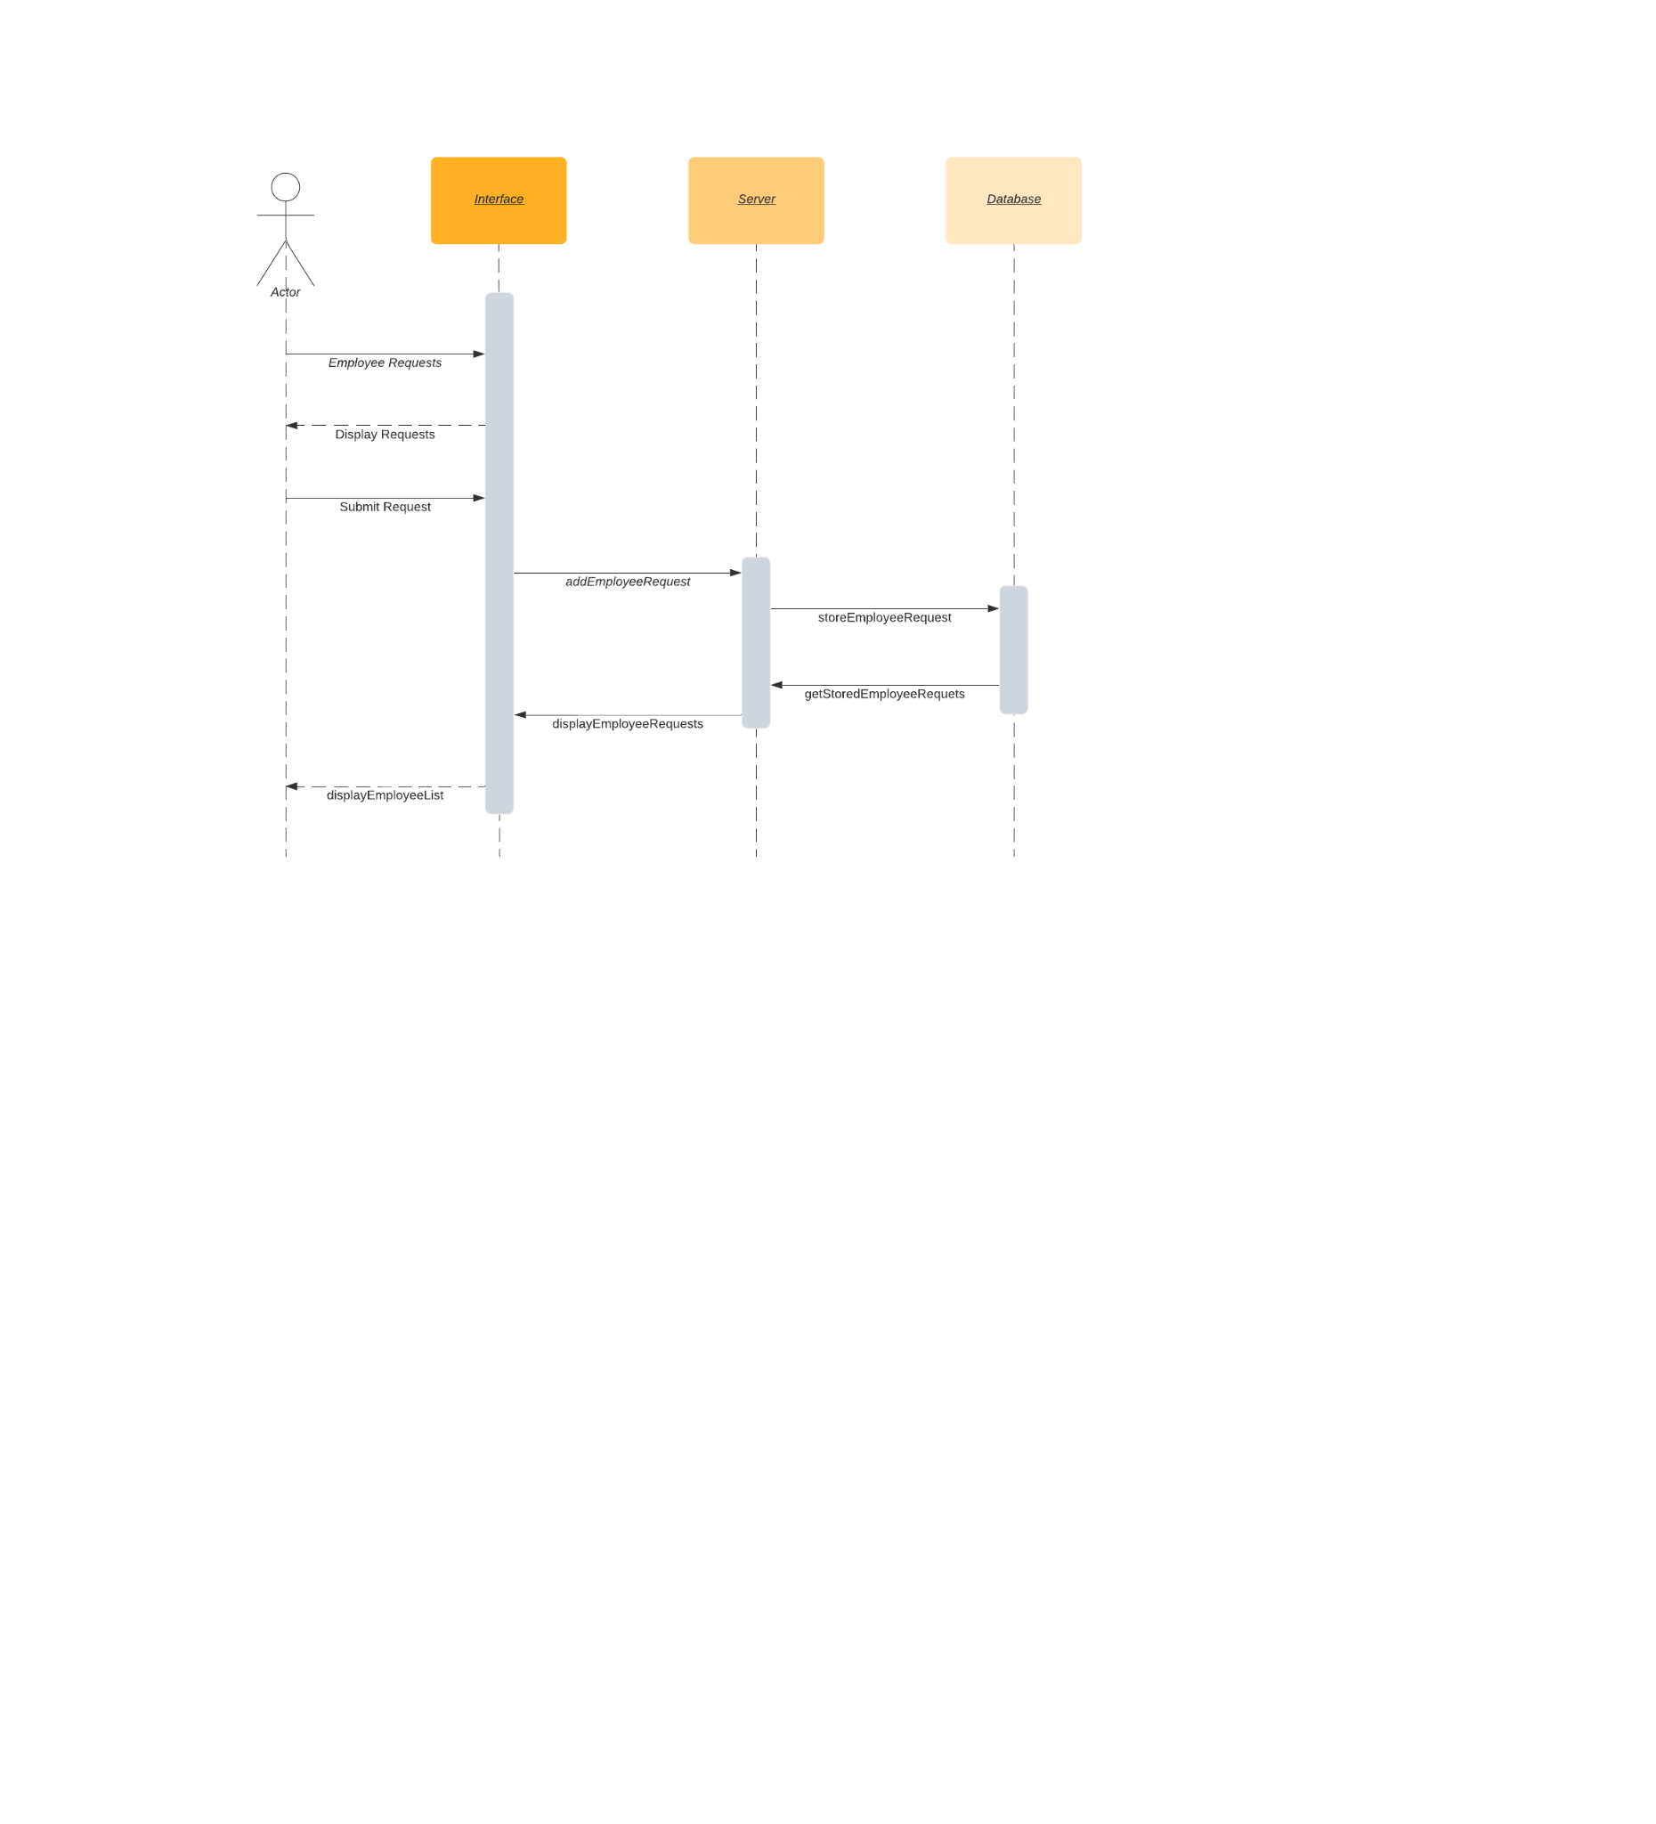

### 5.15 Employee Review:

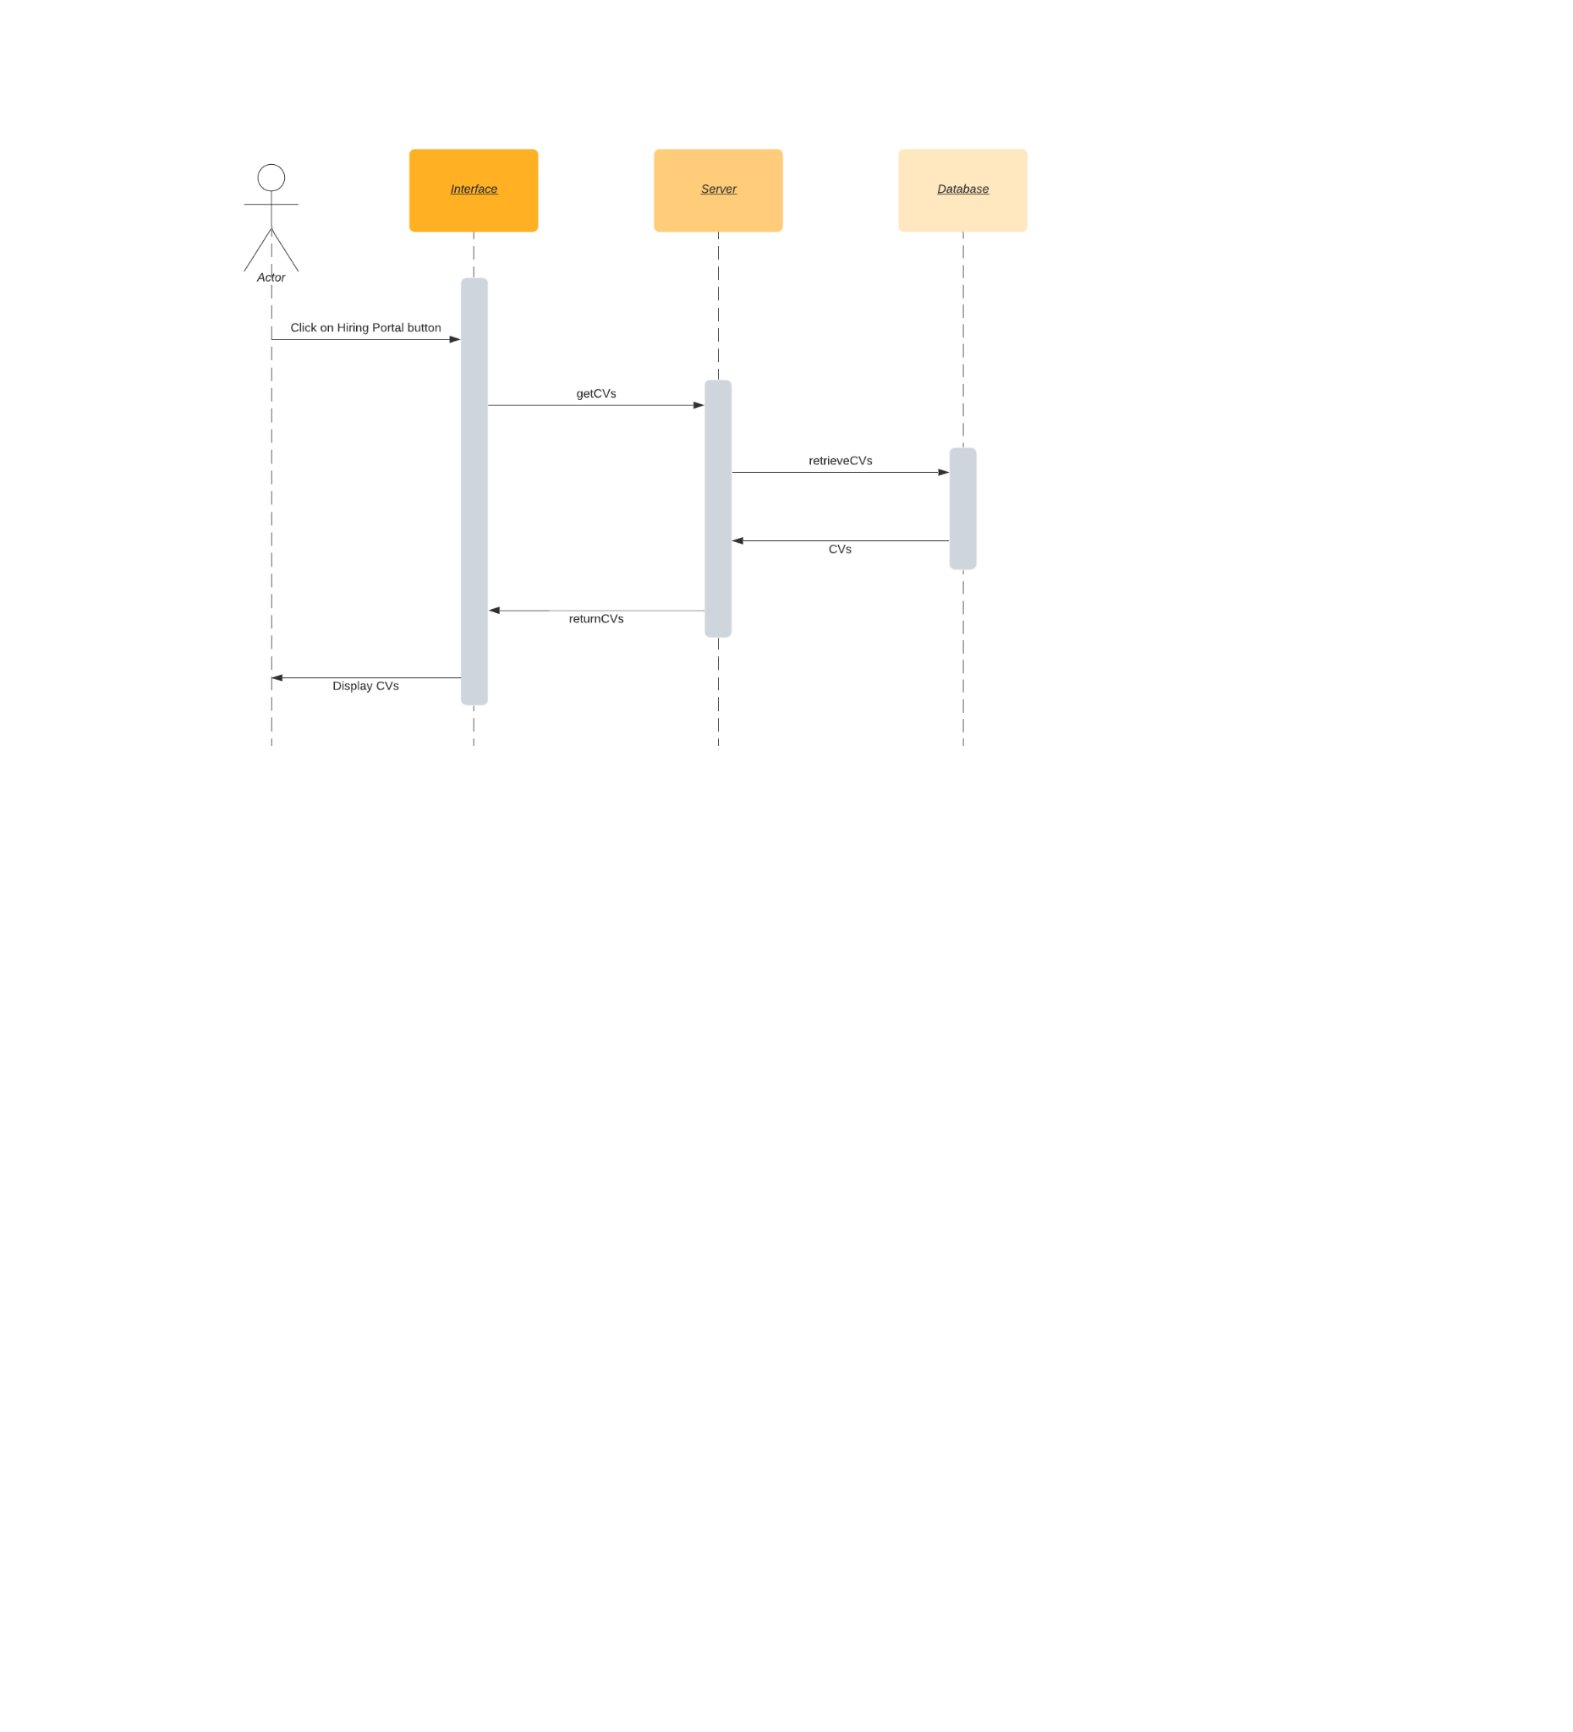

### 5.16 Employee Reviews Reminder

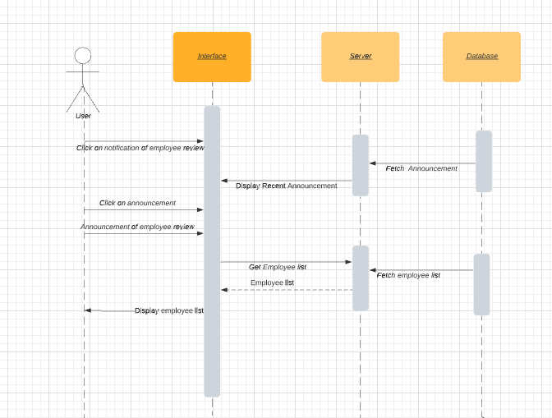

### 5.17 Hiring Portal:

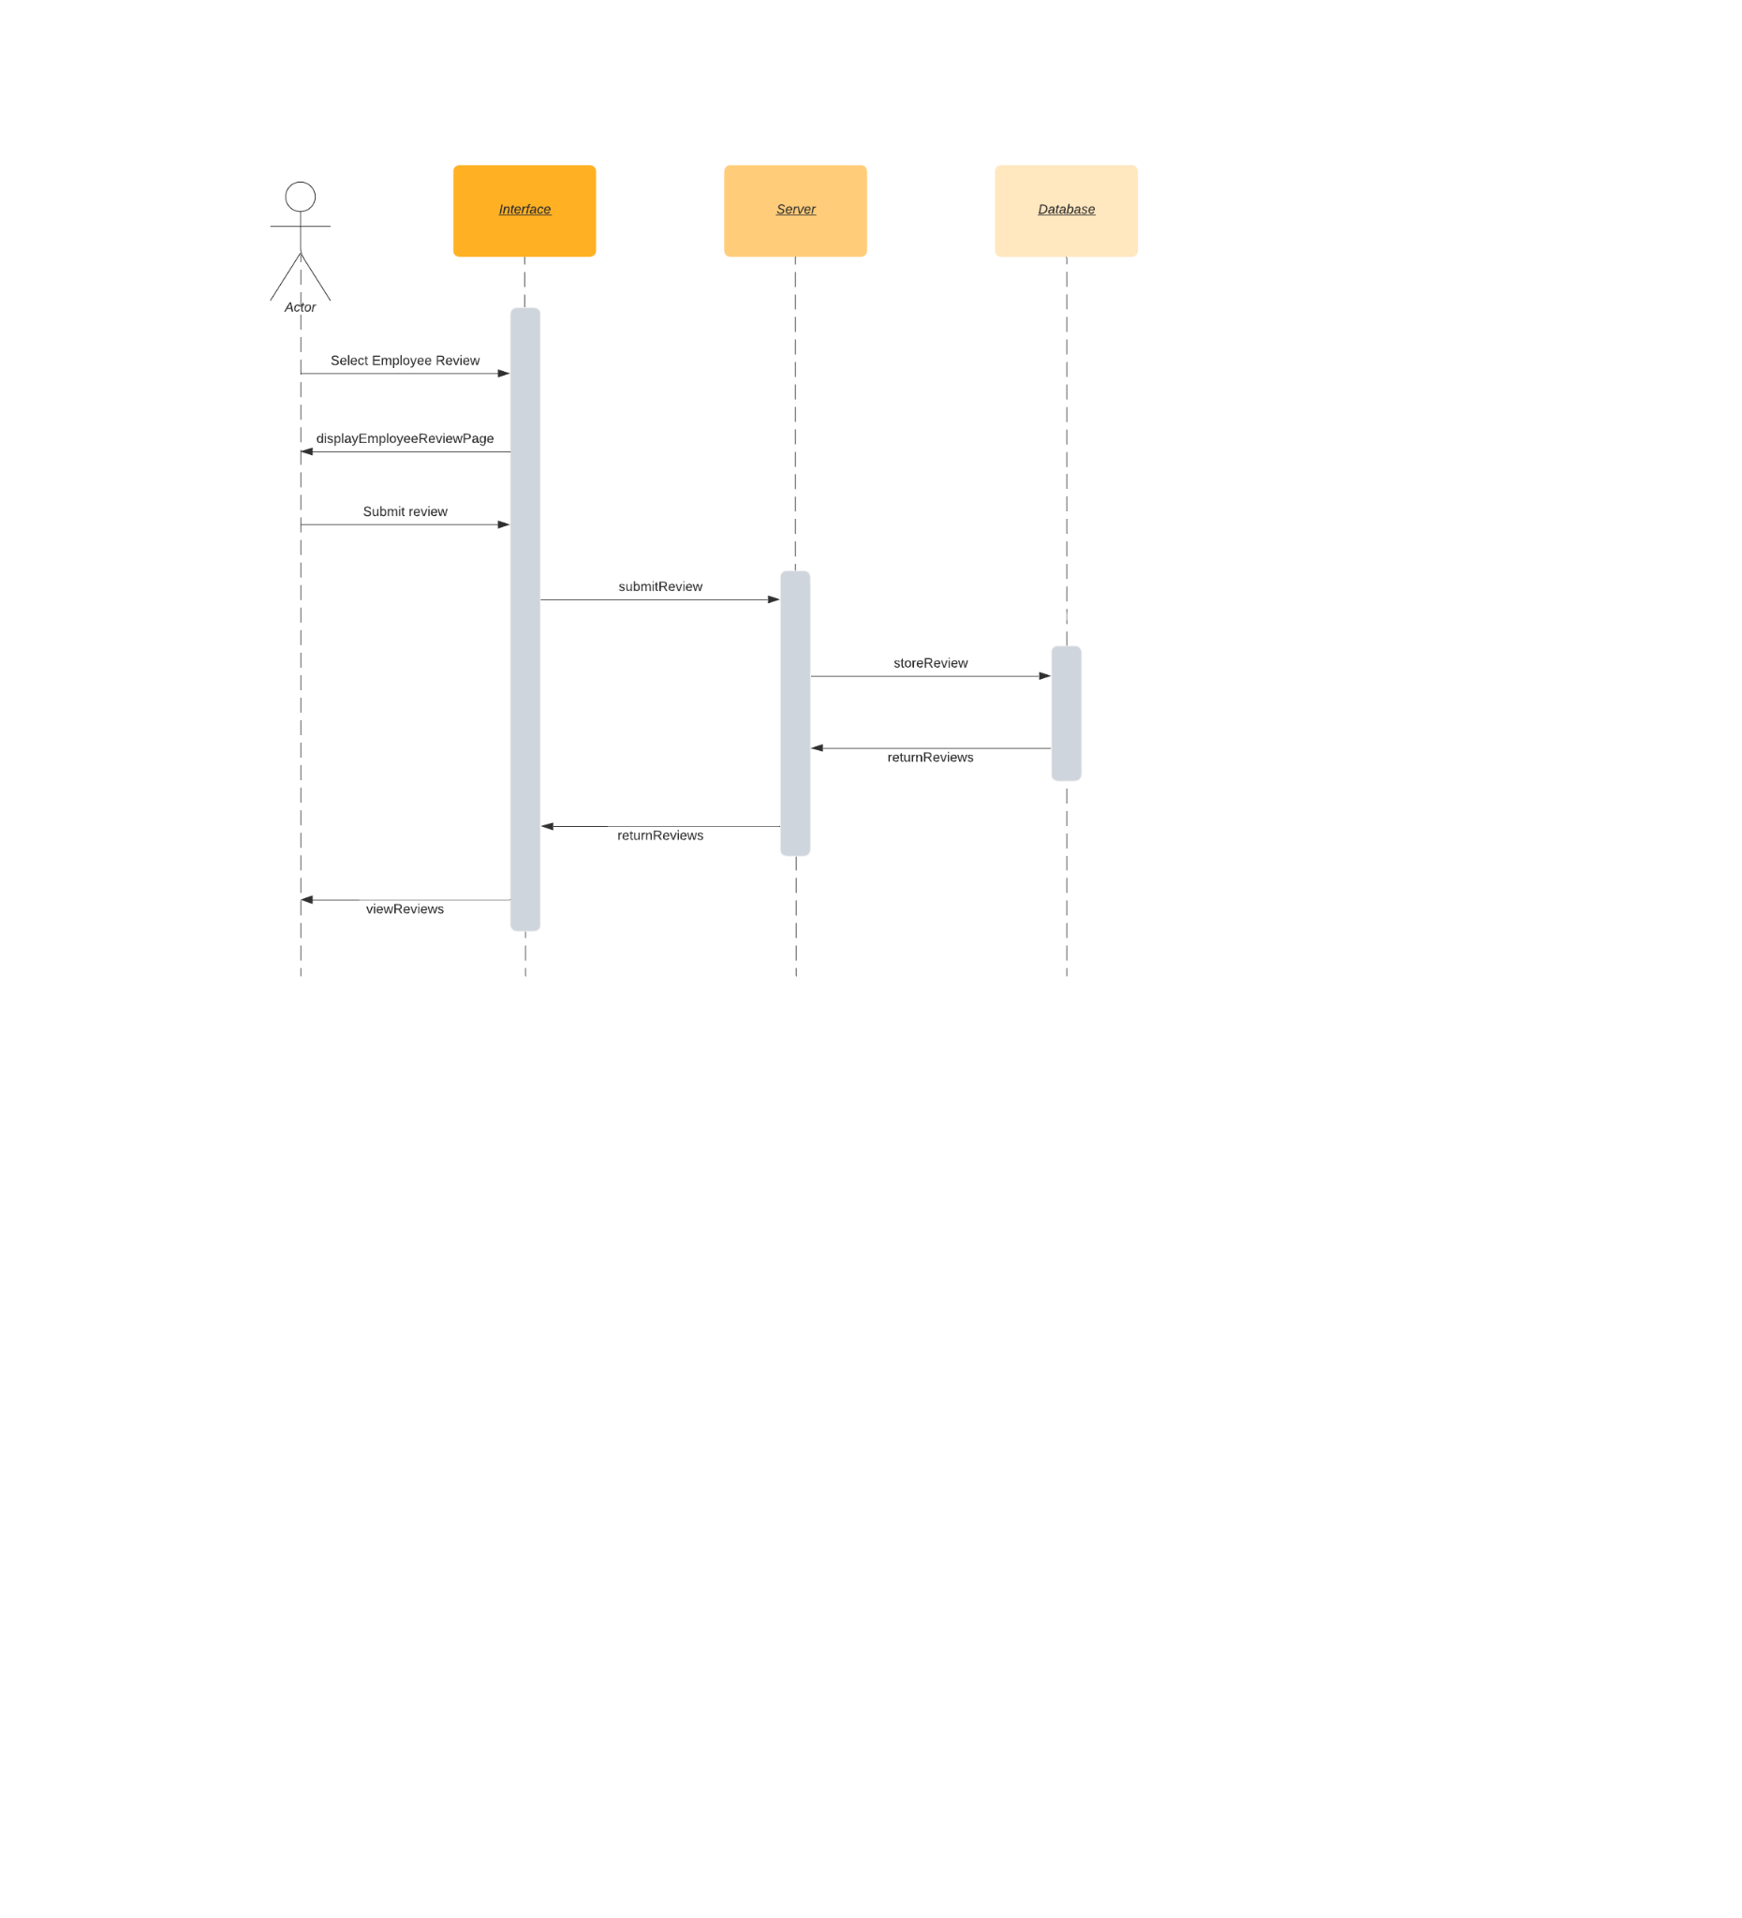

### 5.18 Notifications:

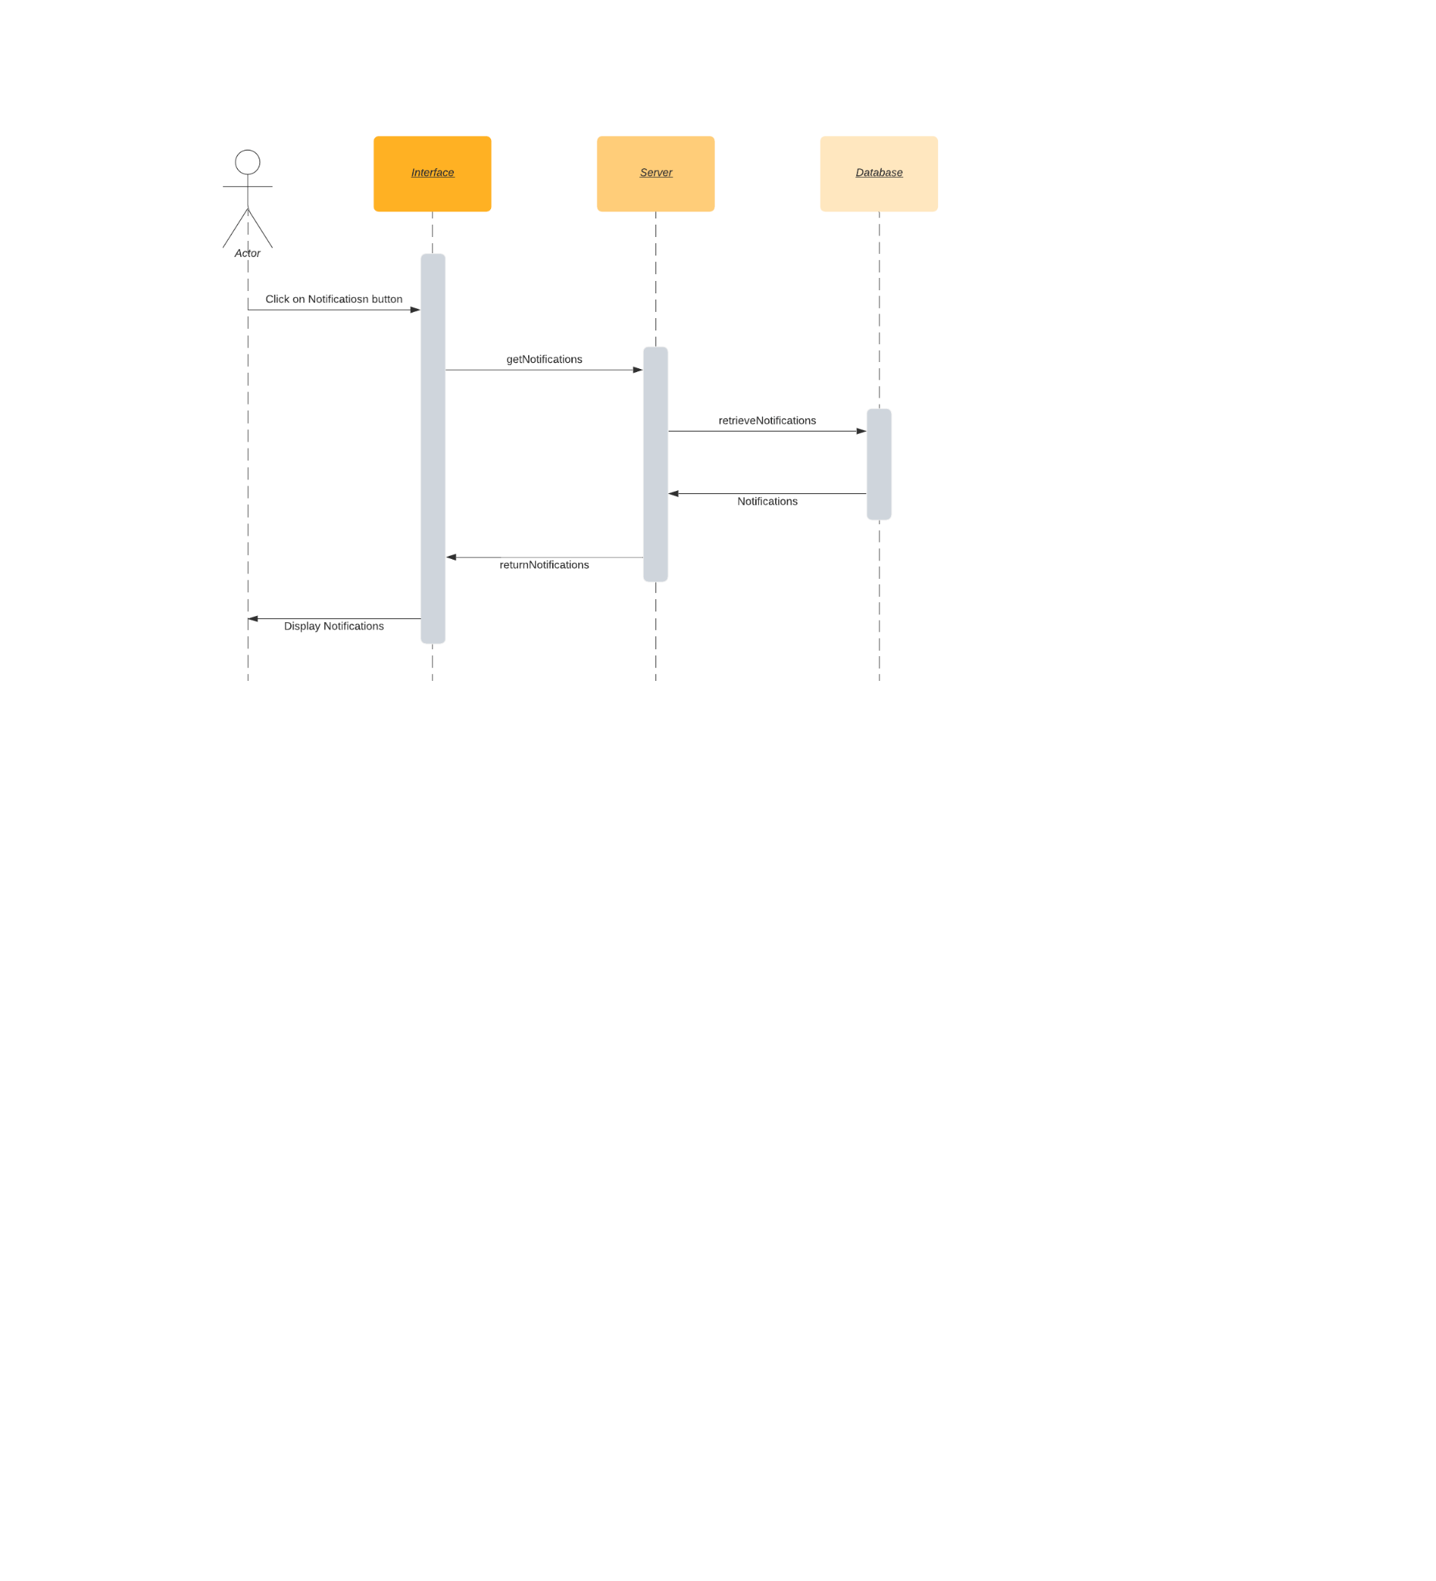

### 5.19 Staff directory:

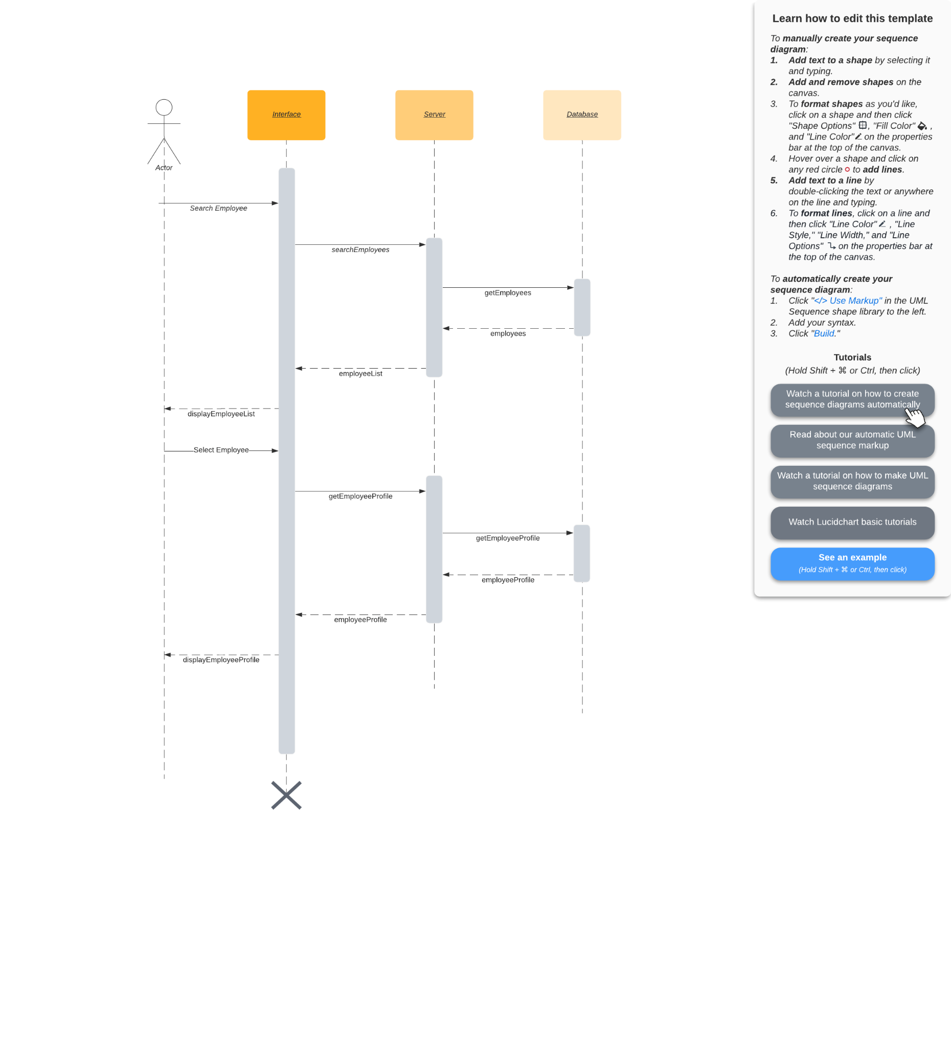

### 5.20 AI Chatbot

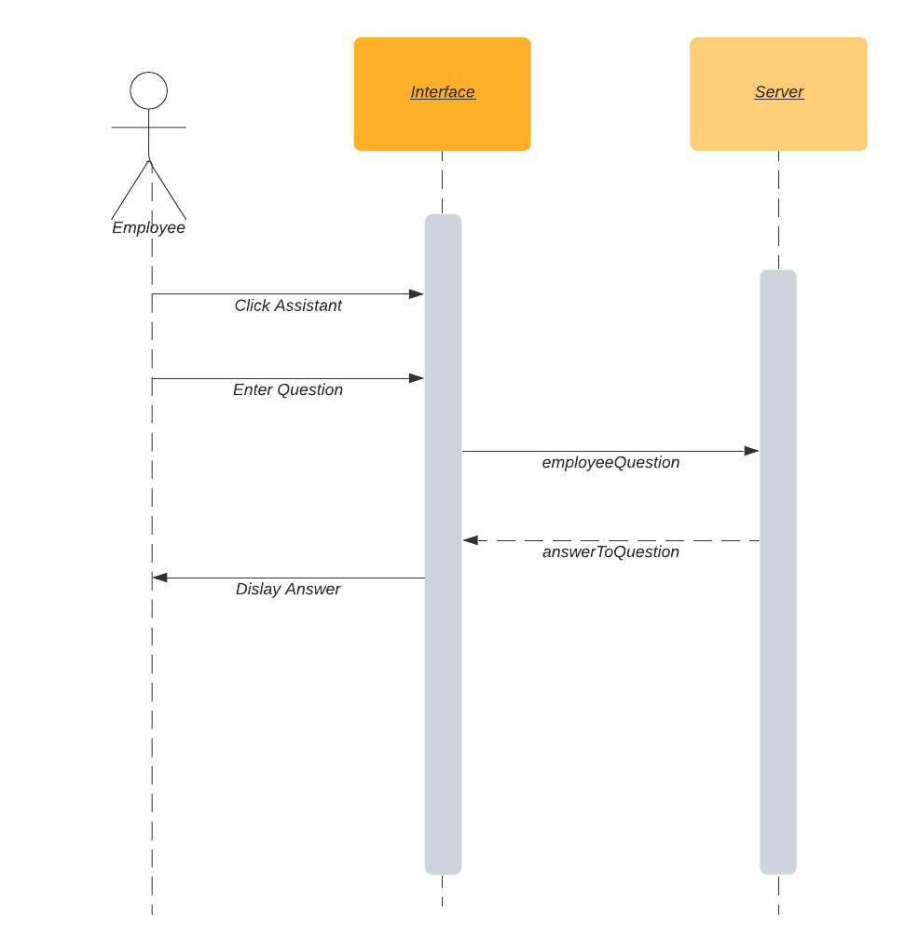

### 5.21 Hiring Candidates

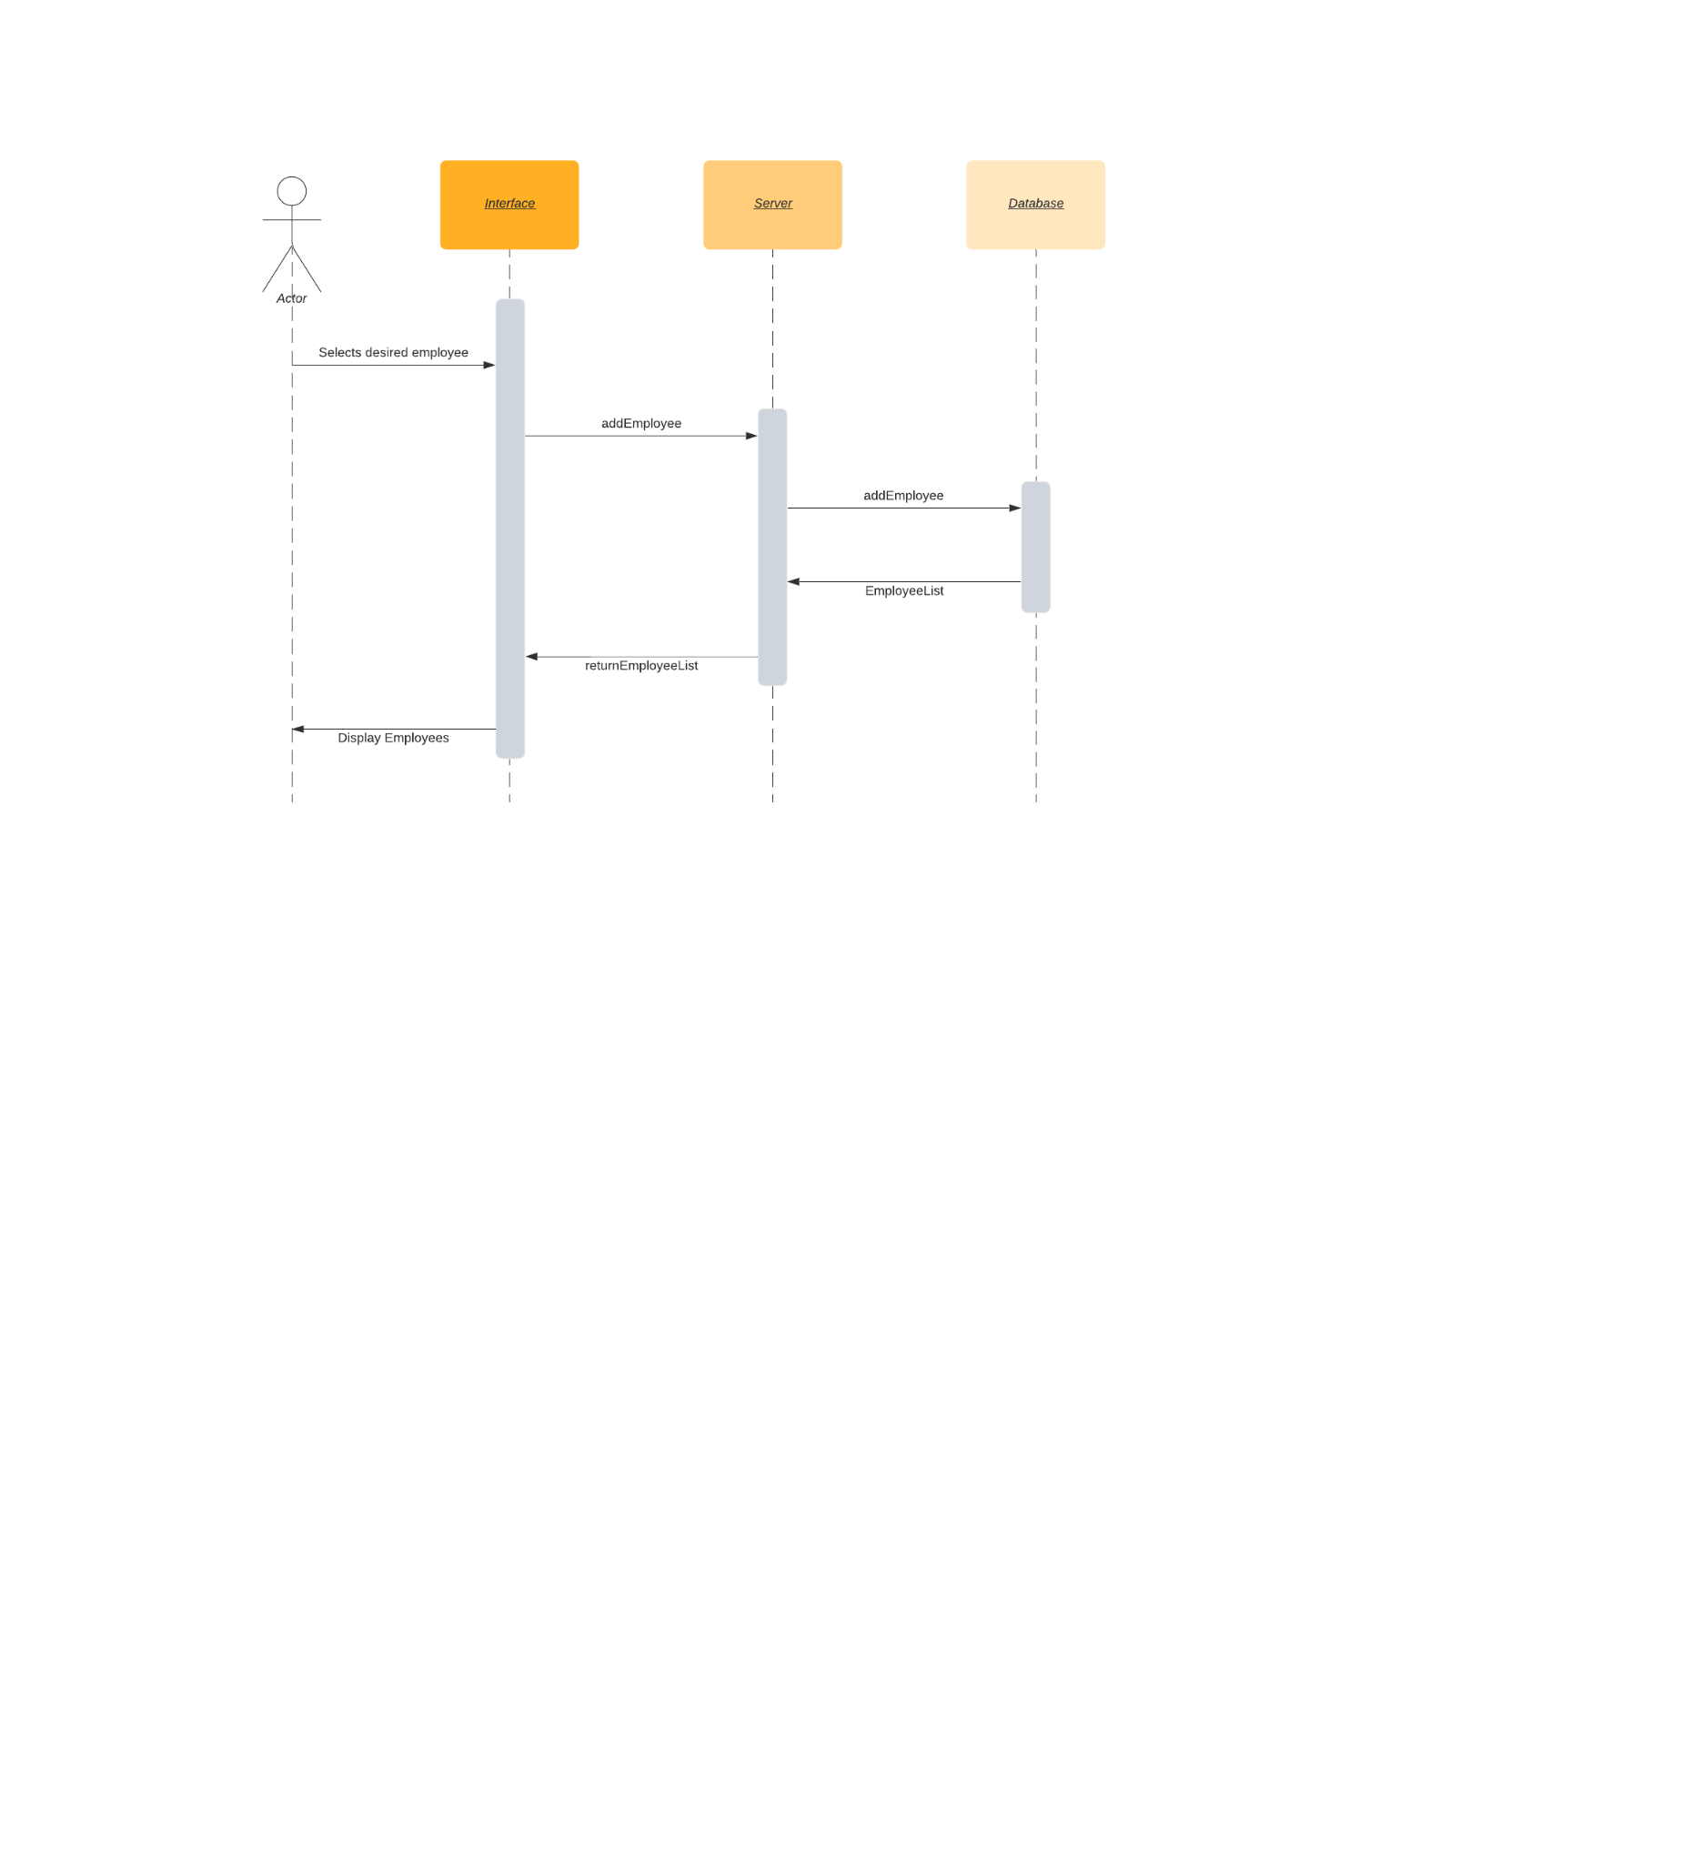

### 5.22 Employee Request Accept/Denial

**Revised sequence Diagrams:**

**1.Compensation and benefits:**

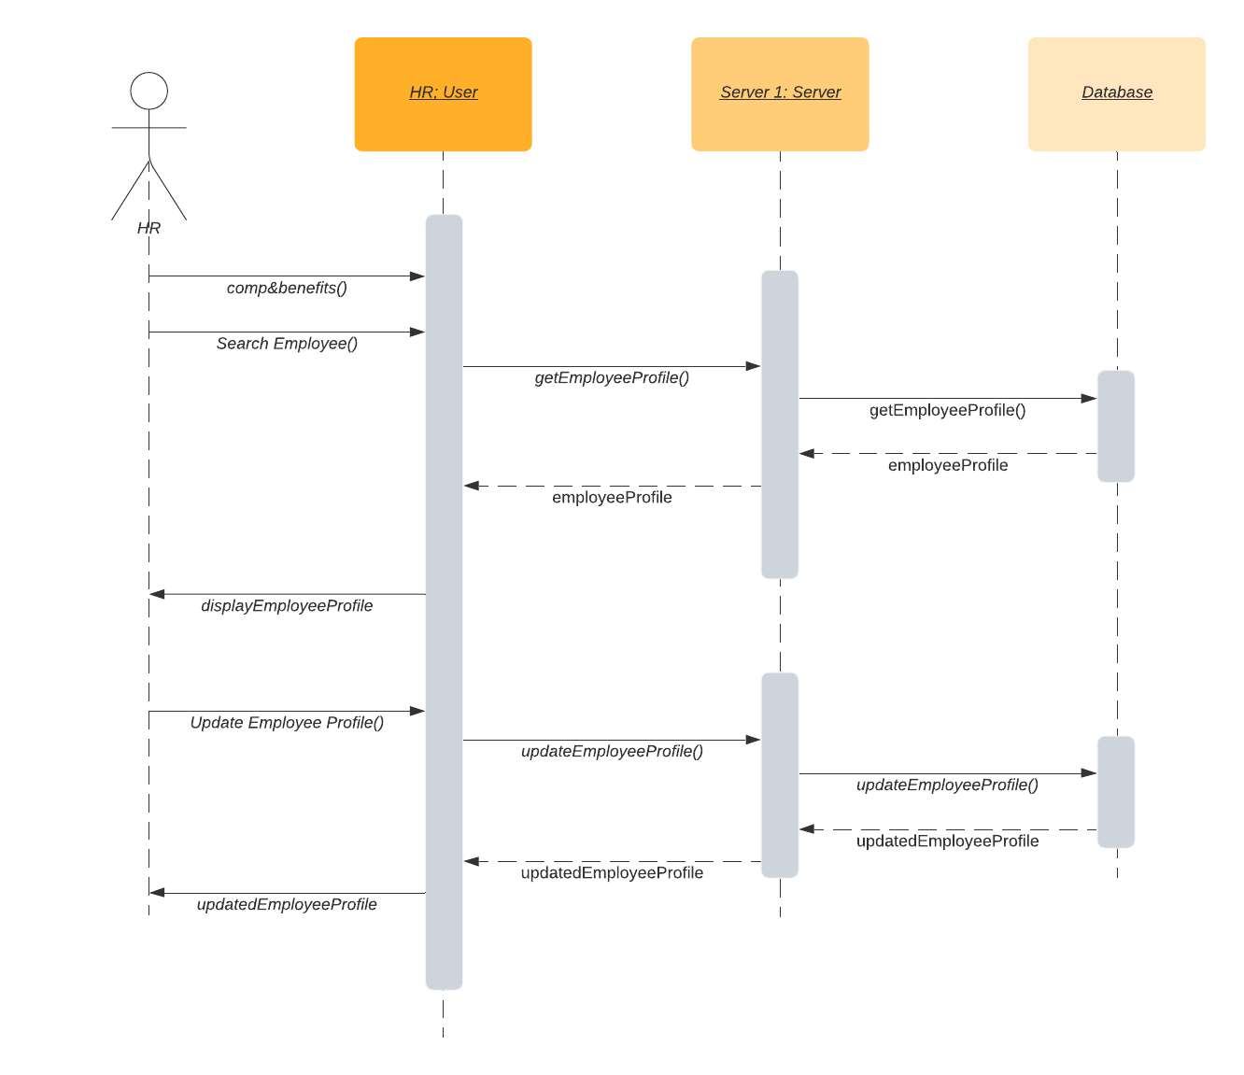

**2. CV parsing**

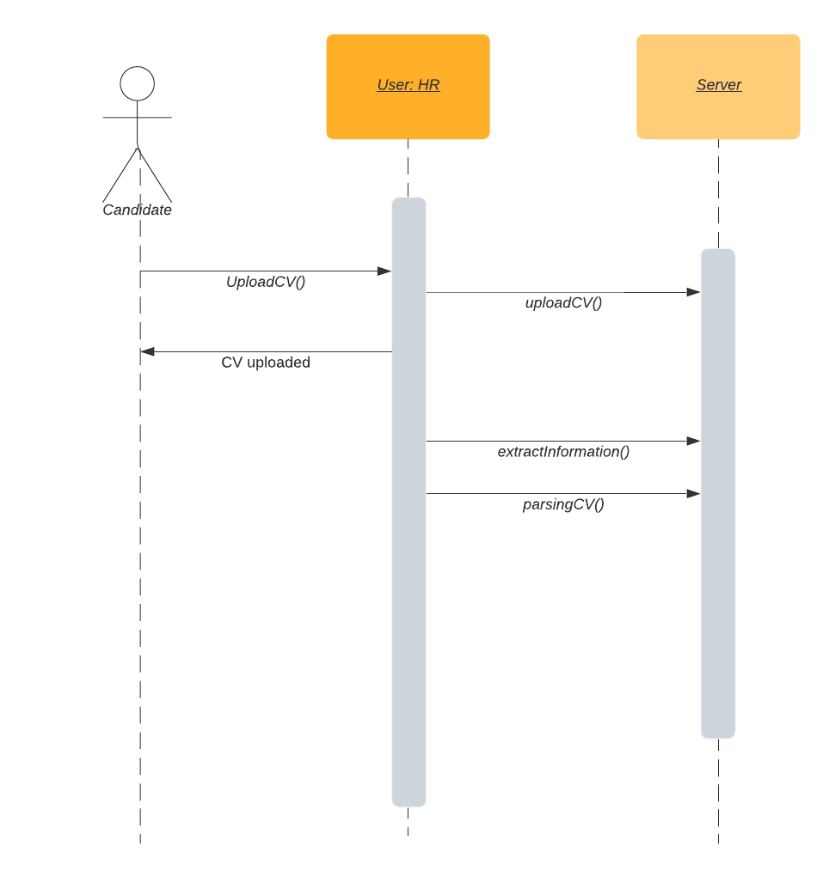

**3. Job Posting**

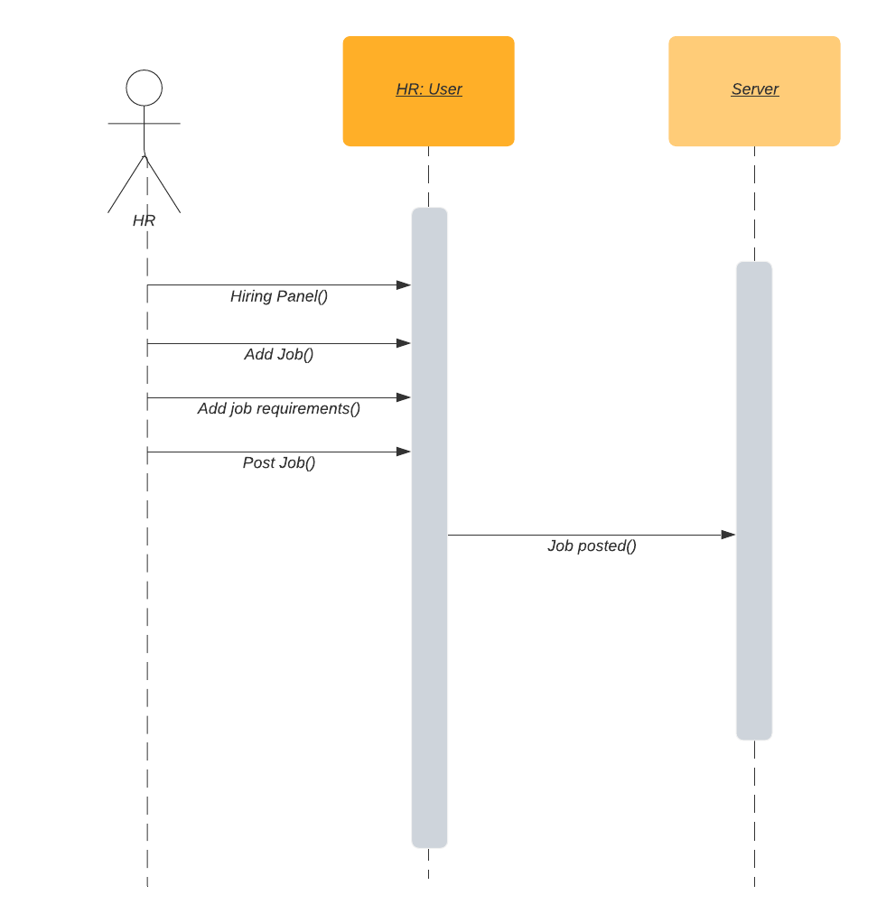

**4.View hierarchy**

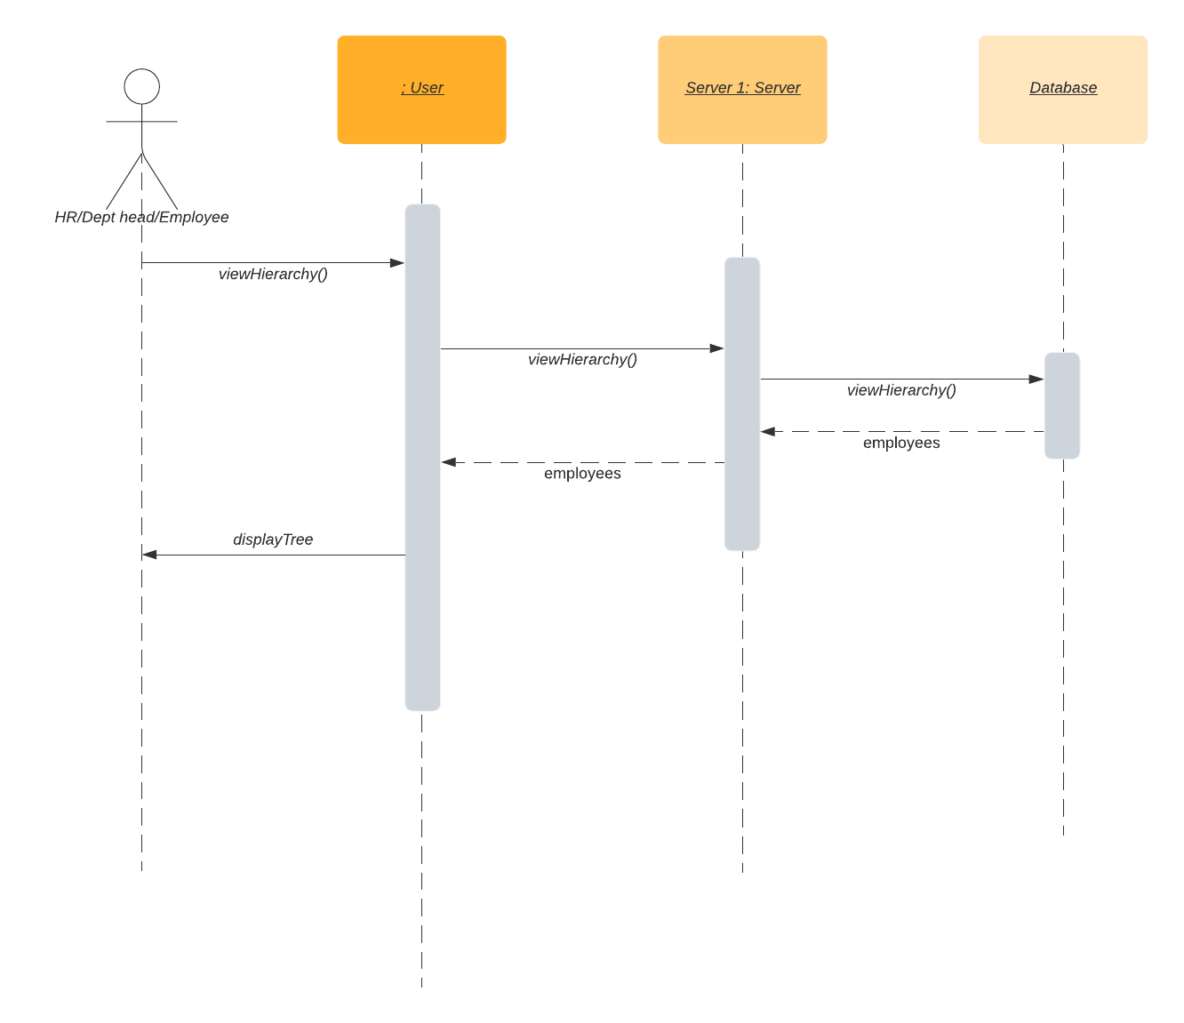

**5.Manage Departments**

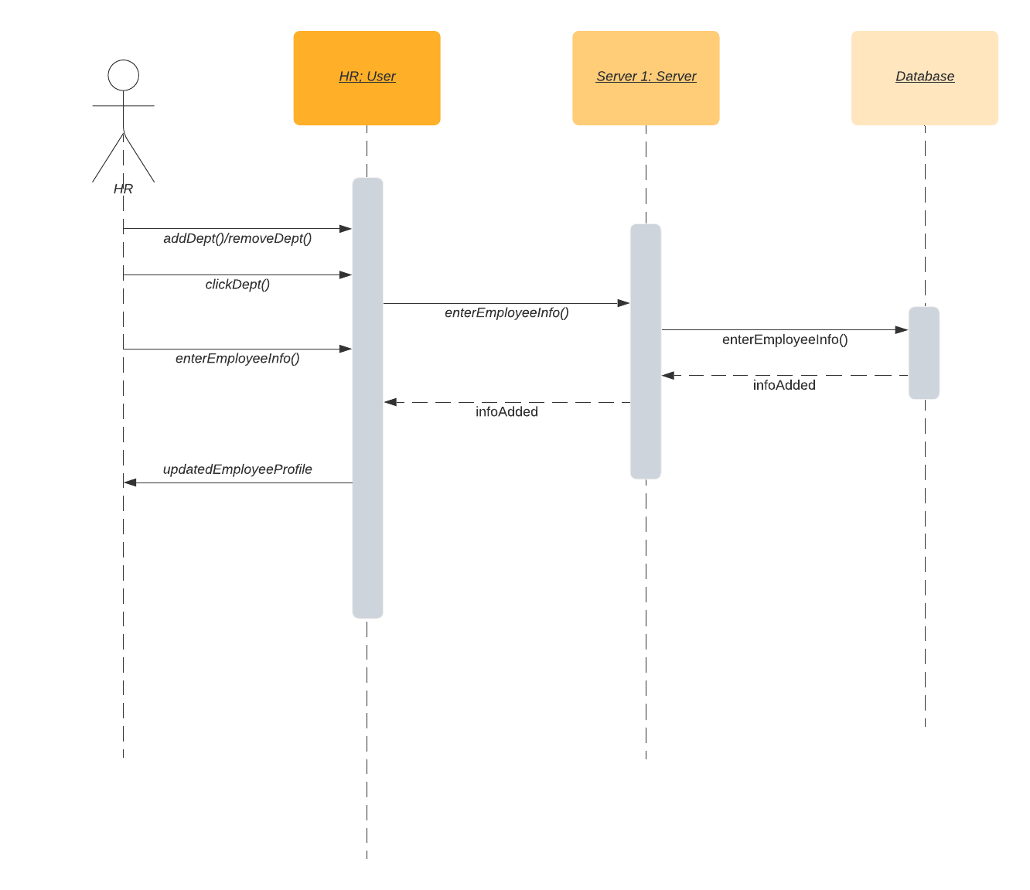

# State Diagrams

## Diagram details

Diagram 1:

This Diagram shows the state changes in the Hiring portal. As soon as the CV is uploaded, the system parses the CV and matches it with job requirements and then assigns it a rank. Then, if the candidate is selected, the candidate is added by the HR manager to the database.

Diagram 2:

This diagram shows when the HR updates an employee’s stats. These stats are then added to the employee’s dashboard and the HR manager then has the ability to review the employee’s dashboard.

## Diagram

**1.**

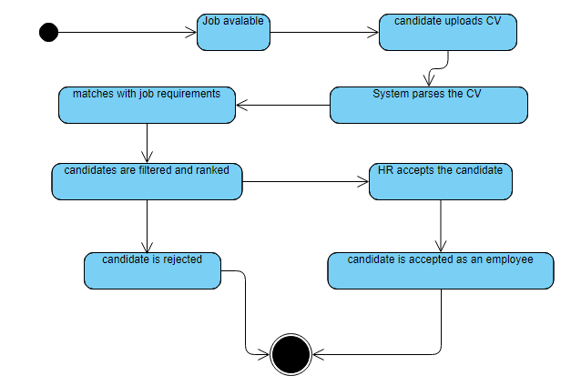

**2.**

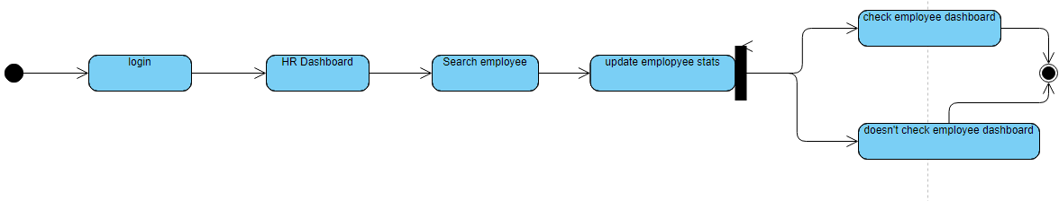

# Non-functional Requirements / Quality Attributes

| **Sr#** | **Requirements** |
| --- | --- |
| **1** | The system shall not fail more than 3 times every 24 hours. In case of a failure, the system should restore to normal operations within 5 minutes of a failure. |
| **2** | Any interaction between the user and the system must have a maximum response time of 4 seconds. In cases where more time is required by the system, the system must display the progress |
| **3** | Personal data of employees shall only be available to the HR manager and System Manager. |
| **4** | Sensitive information of employees such as passwords and personal information shall be encrypted and must not be available to anyone except the system administrator. |
| **5** | The number of the simultaneous users of the system can accommodate shall be 50 |
| **6** | Only 5000 employees can be added to the database. |
| **7** | The system shall be reliable i.e information entered should be stored successfully. |
| **8** | System shall distinguish authorization levels based on the actor  Authorization levels will be hierarchical ( e.g Dept heads will be able to access information of their subordinates and the subordinates will be able to access data of the employees working under them respectively.) |
| **9** | The software shall be used on PCs and be functional via the internet using all major web browsers i.e Safari, Chrome and Firefox |
| **10** | The website shall display errors/notifications in cases of failures  For unexpected failures the users should be notified and they should be able to go back to the previous page. |
| **11** | At least 20% of the processor and RAM capacity shall be unused at peak load periods. |

1. **Who did what?**

# 

| **Name of the Team Member** | **Tasks done** |
| --- | --- |
| **Mohammad Yousuf** | Use-case diagram, state diagram, use cases |
| **Aamina Mariam** | Class diagram and sequence diagrams |
| **Talha Nasir** | Most of the use-cases, formatting, Introduction |
| **Javeria Tariq** | Sequence diagrams, use cases, formatting |
| **Ali Adnan Arif** | Sequence diagrams, formatting, introduction, |

# Review checklist

Before submission of this deliverable, the team must perform an internal review. Each team member will review one or more sections of the deliverable.

| **Section** **Title** | **Reviewer Name(s)** |
| --- | --- |
| Introduction (section 1) | Talha, Adnan |
| Actors (section 2) | Javeria |
| Use cases (section 3) | Talha, Adnan |
| Class diagram (section 4) | Yousuf, Javeria |
| Sequence diagrams (section 5) | Talha, Adnan |
| State diagrams (section 6) | Aamina |
| Non - Functional requirements (section 7) | Yousuf |